**Information about Marine World**

Name : G S SRENATH KUMAR Unique Id:E0120006

Students Team:

Name of the student:

G S SRENATH KUMAR Unique Id:E0120006

**Code and Outputs for Level 1-5**

-------------------------------------------------------------------------------------------------------------------------------

**LEVEL-1**

**Level 1 Code and Level 2 Code:**

**File 1: level1.html:**

<!DOCTYPE html>

<html>

<head>

<meta charset="utf-8">

<meta name="viewport" content="width=device-width, initial-scale=1, shrink-to-fit=no">

<title>Information About Marine Life</title>

<link href="navbar.css" rel="stylesheet" type="text/css">

<link rel="stylesheet" href="https://stackpath.bootstrapcdn.com/bootstrap/4.5.2/css/bootstrap.min.css">

<link rel="stylesheet" href="https://maxcdn.bootstrapcdn.com/font-awesome/4.7.0/css/font-awesome.min.css">

<script src="https://code.jquery.com/jquery-3.5.1.min.js"></script>

<script src="https://cdn.jsdelivr.net/npm/popper.js@1.16.1/dist/umd/popper.min.js"></script>

<script src="https://stackpath.bootstrapcdn.com/bootstrap/4.5.2/js/bootstrap.min.js"></script>

<style type="text/css">

body {

background-image: url('background_image.jpg');

background-repeat: no-repeat;

background-attachment: fixed;

background-size: 100% 100%;

}

img {

border-radius: 50%;

display: block;

margin-left:;

margin-right: auto;

}

img2 {

border-radius: 50%;

display: block;

margin-left:;

margin-right: auto;

}

.container {

position: relative;

text-align: 15px;

color: green;

font-size: 150%

}

.container1 {

position: relative;

text-align: 15px;

color: green;

font-size: 150%

}

.container2 {

position: relative;

text-align: 15px;

color: green;

font-size: 150%

}

.container3 {

position: relative;

text-align: 15px;

color: green;

font-size: 150%

}

.container4 {

position: relative;

text-align: 15px;

color: green;

font-size: 150%

}

.bottom-left {

position: absolute;

bottom: 10px;

left: 10px;

}

.contain {

display: flex;

align-items: center;

justify-content: center

}

.text {

font-size: 10px;

padding-left: 10px;

color: black;

}

.content121{

padding: 15px;

font-size: 18px;

background: #5ec40c;

margin-bottom: 15px;

}

.content121.bg-alt{

background: blue;

}

</style>

</head>

<body>

<h1 style="text-align:center;" ><span style="color: powderblue">INFORMATION ABOUT MARINE WORLD</span></h1>

<img src="logo.jpg" alt="dd" width="90" height="90">

<div class="navBAR">

<ul>

<li><a href="https://en.wikipedia.org/wiki/Seabird"> SEA BIRDS </a>

<ul>

<li><a href="https://en.wikipedia.org/wiki/Caspian_tern">CASPIAN TERN</a></li>

<li><a href="https://en.wikipedia.org/wiki/Heermann%27s_gull">HEERMANN'S GULL</a></li>

<li><a href="https://en.wikipedia.org/wiki/Great_blue_heron">GREAT BLUE HERON</a></li>

<li><a href="https://en.wikipedia.org/wiki/Great_white_pelican">GREAT WHITE PELICAN</a></li>

</ul>

</ul>

<ul>

<li><a href="https://en.wikipedia.org/wiki/Fishes"> SEA FISHES </a>

<ul>

<li><a href="https://en.wikipedia.org/wiki/Salmon">SALMON</a></li>

<li><a href="https://en.wikipedia.org/wiki/Cod">COD</a></li>

<li><a href="https://en.wikipedia.org/wiki/Herring">HERRING</a></li>

<li><a href="https://en.wikipedia.org/wiki/Rainbow_trout">RAINBOW TROUT</a></li>

</ul>

</ul>

<ul>

<li><a href="https://en.wikipedia.org/wiki/Reptile"> SEA REPTILES </a>

<ul>

<li><a href="https://en.wikipedia.org/wiki/Sea_turtle">SEA TURTLES</a></li>

<li><a href="https://en.wikipedia.org/wiki/Crocodile">CROCODILES</a></li>

<li><a href="https://en.wikipedia.org/wiki/Dinosaur">DINOSAURS</a></li>

<li><a href="https://en.wikipedia.org/wiki/Snake">SNAKES</a></li>

</ul>

</ul>

<ul>

<li><a href="https://en.wikipedia.org/wiki/Sea_lion"> SEA LIONS </a>

<ul>

<li><a href="https://en.wikipedia.org/wiki/Sea_lion">PACIFIC POINT PRESERVE</a></li>

<li><a href="https://en.wikipedia.org/wiki/Sea_lion">SEA COVE LION</a></li>

</ul>

</ul>

<ul>

<li><a href="https://en.wikipedia.org/wiki/Shark"> SEA SHARKS AND RAYS </a>

<ul>

<li><a href="https://en.wikipedia.org/wiki/Hammerhead_shark">GREAT WHITE SHARK</a></li>

<li><a href="https://en.wikipedia.org/wiki/Whale_shark">WHALE SHARK</a></li>

<li><a href="https://en.wikipedia.org/wiki/Hammerhead_shark">HAMMERHEAD SHARK</a></li>

<li><a href="https://en.wikipedia.org/wiki/Tiger_shark">TIGER SHARK</a></li>

</ul>

</ul>

</div>

<h6>.</h6>

<p>.</p>

<h1 style="color:RED;">SEA LIFE SOCIETY</h1>

<p style="background-color:powderblue;">We invite you to explore the depths of MarineBio and find out about marine species, ocean conservation, research,

and 101+ Ways to Make a Difference Today. Make your voice heard by contacting us or participating in any of our social

networking sites: Instagram, Facebook, Twitter, Pinterest, etc. Together our efforts are making the difference needed so

that our ocean’s many wonderful species (including us) will be able to thrive and survive.MarineBio is an ever-evolving

tribute to all ocean life that has been a central source online for the latest information concerning marine life and its

biology, and especially its conservation, since 1998..</p>

<p>.</p>

<h2 style="color:red;">SEA BIRDS<h2>

<div class="contain">

<div class="container">

<a href="https://en.wikipedia.org/wiki/Seabird">

<img src="bird.jpg" alt="https://en.wikipedia.org/wiki/Seabird" width="200" height="200">

</div>

</a>

</div>

<div class="text" style="color:white;">

<h5>Seabirds (also known as marine birds) are birds that are adapted

to life within the marine environment. While seabirds vary greatly in

lifestyle, behaviour and physiology, they often exhibit striking convergent

evolution, as the same environmental problems and feeding niches have resulted

in similar adaptations. The first seabirds evolved in the Cretaceous period,

and modern seabird families emerged in the Paleogene.</h5>

</div>

<h2 style="color:blue;">SEA FISHES<h2>

<div class="container4">

<a href="https://en.wikipedia.org/wiki/Fishes">

<img src="fishes.jpg" alt="https://en.wikipedia.org/wiki/Fishes" width="200" height="200">

</a>

</div>

<div class="text" style="color:white;">

<h5>Deep-sea fish are fish that live in the darkness below the sunlit surface waters,

that is below the epipelagic or photic zone of the sea. The lanternfish is, by far,

the most common deep-sea fish. Other deep sea fishes include the flashlight fish,

cookiecutter shark, bristlemouths, anglerfish, viperfish, and some species of eelpout.</h5>

</div>

<h2 style="color:yellow;">SEA REPTILES<h2>

<div class="container1">

<a href="https://en.wikipedia.org/wiki/Reptile">

<img src="reptiles.jpg" alt="https://en.wikipedia.org/wiki/Reptile" width="200" height="200">

</a>

</div>

<div class="text" style="color:white;">

<h5>Marine reptiles are reptiles which have become secondarily adapted for an aquatic

or semiaquatic life in a marine environment.The earliest marine reptiles arose in the

Permian period during the Paleozoic era. During the Mesozoic era, many groups of reptiles

became adapted to life in the seas, including such familiar clades as the ichthyosaurs,

plesiosaurs (these two orders were once thought united in the group "Enaliosauria".</h5>

</div>

<h2 style="color:blue;">SEA LIONS<h2>

<div class="container2">

<a href="https://en.wikipedia.org/wiki/Sea_lion">

<img src="lions.jpg" alt="https://en.wikipedia.org/wiki/Sea_lion" width="200" height="200">

</a>

</div>

<div class="text" style="color:white;">

<h5>Sea lions are pinnipeds characterized by external ear flaps, long foreflippers,

the ability to walk on all fours, short, thick hair, and a big chest and belly.

Together with the fur seals, they comprise the family Otariidae, eared seals, which

contains six extant and one extinct species (the Japanese sea lion) in five general</h5>

</div>

<h2 style="color:red;">SEA SHARK AND RAYS<h2>

<div class="container3">

<a href="https://en.wikipedia.org/wiki/Sea_lion">

<img src="sharks.jpg" alt="https://en.wikipedia.org/wiki/Sea_lion" width="200" height="200">

</a>

</div>

<div class="text" style="color:white;">

<h5>Sharks are a group of elasmobranch fish characterized by a cartilaginous skeleton,

five to seven gill slits on the sides of the head, and pectoral fins that are not fused

to the head. Modern sharks are classified within the clade Selachimorpha </h5>

</div>

<p>.</p>

<p>.</p>

<h4 style="text-align:center;" ><span style="background-color:powderblue;">LIFE EXTINCT OF THE SEA ANIMALS</span></h2>

<h3 class="text-center"><span style="background-color:powderblue;">DEATH GREATER THAN 1 MILLION(10 LAKHS) PER YEAR</span></h3>

<div class="container mt-3">

<div class="row">

<div class="col-md-2">

<a href="https://www.motherjones.com/environment/2020/01/a-new-study-death-of-1-million-common-murres/">

<div class="content121">SEA BIRDS</div>

</a>

</div>

<div class="col-md-10">

<a href="https://www.theguardian.com/us-news/2021/feb/01/california-sea-lion-deaths-cancer-toxic-chemicals">

<div class="content121 bg-alt">SEA LIONS</div>

</a>

</div>

</div>

<div class="row">

<div class="col-md-9">

<a href="https://interestingengineering.com/colossal-triassic-reptile-died-after-eating-massive-lizard#:~:text=Colossal%20marine%20reptile%20died%20shortly,have%20appeared%20like%20friendly%20dolphins.">

<div class="content121">SEA REPTILES</div>

</a>

</div>

<div class="col-md-3">

<a href="https://en.wikipedia.org/wiki/Fish_kill#:~:text=The%20most%20common%20cause%20is,common%20cause%20of%20fish%20kill.">

<div class="content121 bg-alt">SEA FISHES</div>

</a>

</div>

</div>

<div class="row">

<div class="col-md-8">

<a href="https://www.surfertoday.com/surfing/the-most-shark-infested-waters-in-the-world">

<div class="content121">SEA SHARKS</div>

</a>

</div>

<div class="col-md-4">

<div class="content121 bg-alt">SEA RAYS</div>

</div>

</div>

</div>

</body>

</html>

**File 2: level2.html**

**<!DOCTYPE html>**

**<html>**

**<head>**

**<meta charset="utf-8">**

**<meta name="viewport" content="width=device-width, initial-scale=1, shrink-to-fit=no">**

**<title>Information About Marine Life</title>**

**<link href="navbar.css" rel="stylesheet" type="text/css">**

**<link rel="stylesheet" href="https://stackpath.bootstrapcdn.com/bootstrap/4.5.2/css/bootstrap.min.css">**

**<link rel="stylesheet" href="https://maxcdn.bootstrapcdn.com/font-awesome/4.7.0/css/font-awesome.min.css">**

**<script src="https://code.jquery.com/jquery-3.5.1.min.js"></script>**

**<script src="https://cdn.jsdelivr.net/npm/popper.js@1.16.1/dist/umd/popper.min.js"></script>**

**<script src="https://stackpath.bootstrapcdn.com/bootstrap/4.5.2/js/bootstrap.min.js"></script>**

**<style type="text/css">**

**body {**

**background-image: url('background_image.jpg');**

**background-repeat: no-repeat;**

**background-attachment: fixed;**

**background-size: 100% 100%;**

**}**

**img {**

**border-radius: 50%;**

**display: block;**

**margin-left:;**

**margin-right: auto;**

**}**

**img2 {**

**border-radius: 50%;**

**display: block;**

**margin-left:;**

**margin-right: auto;**

**}**

**.container {**

**position: relative;**

**text-align: 15px;**

**color: green;**

**font-size: 150%**

**}**

**.container1 {**

**position: relative;**

**text-align: 15px;**

**color: green;**

**font-size: 150%**

**}**

**.container2 {**

**position: relative;**

**text-align: 15px;**

**color: green;**

**font-size: 150%**

**}**

**.container3 {**

**position: relative;**

**text-align: 15px;**

**color: green;**

**font-size: 150%**

**}**

**.container4 {**

**position: relative;**

**text-align: 15px;**

**color: green;**

**font-size: 150%**

**}**

**.bottom-left {**

**position: absolute;**

**bottom: 10px;**

**left: 10px;**

**}**

**.contain {**

**display: flex;**

**align-items: center;**

**justify-content: center**

**}**

**.text {**

**font-size: 10px;**

**padding-left: 10px;**

**color: black;**

**}**

**.content121{**

**padding: 15px;**

**font-size: 18px;**

**background: #5ec40c;**

**margin-bottom: 15px;**

**}**

**.content121.bg-alt{**

**background: blue;**

**}**

**</style>**

**</head>**

**<body>**

**<h1 style="text-align:center;" ><span style="color: powderblue">INFORMATION ABOUT MARINE WORLD</span></h1>**

**<img src="logo.jpg" alt="dd" width="90" height="90">**

**<div class="navBAR">**

**<ul>**

**<li><a href="https://en.wikipedia.org/wiki/Seabird"> SEA BIRDS </a>**

**<ul>**

**<li><a href="https://en.wikipedia.org/wiki/Caspian_tern">CASPIAN TERN</a></li>**

**<li><a href="https://en.wikipedia.org/wiki/Heermann%27s_gull">HEERMANN'S GULL</a></li>**

**<li><a href="https://en.wikipedia.org/wiki/Great_blue_heron">GREAT BLUE HERON</a></li>**

**<li><a href="https://en.wikipedia.org/wiki/Great_white_pelican">GREAT WHITE PELICAN</a></li>**

**</ul>**

**</ul>**

**<ul>**

**<li><a href="https://en.wikipedia.org/wiki/Fishes"> SEA FISHES </a>**

**<ul>**

**<li><a href="https://en.wikipedia.org/wiki/Salmon">SALMON</a></li>**

**<li><a href="https://en.wikipedia.org/wiki/Cod">COD</a></li>**

**<li><a href="https://en.wikipedia.org/wiki/Herring">HERRING</a></li>**

**<li><a href="https://en.wikipedia.org/wiki/Rainbow_trout">RAINBOW TROUT</a></li>**

**</ul>**

**</ul>**

**<ul>**

**<li><a href="https://en.wikipedia.org/wiki/Reptile"> SEA REPTILES </a>**

**<ul>**

**<li><a href="https://en.wikipedia.org/wiki/Sea_turtle">SEA TURTLES</a></li>**

**<li><a href="https://en.wikipedia.org/wiki/Crocodile">CROCODILES</a></li>**

**<li><a href="https://en.wikipedia.org/wiki/Dinosaur">DINOSAURS</a></li>**

**<li><a href="https://en.wikipedia.org/wiki/Snake">SNAKES</a></li>**

**</ul>**

**</ul>**

**<ul>**

**<li><a href="https://en.wikipedia.org/wiki/Sea_lion"> SEA LIONS </a>**

**<ul>**

**<li><a href="https://en.wikipedia.org/wiki/Sea_lion">PACIFIC POINT PRESERVE</a></li>**

**<li><a href="https://en.wikipedia.org/wiki/Sea_lion">SEA COVE LION</a></li>**

**</ul>**

**</ul>**

**<ul>**

**<li><a href="https://en.wikipedia.org/wiki/Shark"> SEA SHARKS AND RAYS </a>**

**<ul>**

**<li><a href="https://en.wikipedia.org/wiki/Hammerhead_shark">GREAT WHITE SHARK</a></li>**

**<li><a href="https://en.wikipedia.org/wiki/Whale_shark">WHALE SHARK</a></li>**

**<li><a href="https://en.wikipedia.org/wiki/Hammerhead_shark">HAMMERHEAD SHARK</a></li>**

**<li><a href="https://en.wikipedia.org/wiki/Tiger_shark">TIGER SHARK</a></li>**

**</ul>**

**</ul>**

**</div>**

**<h6>.</h6>**

**<p>.</p>**

**<h1 style="color:RED;">SEA LIFE SOCIETY</h1>**

**<p style="background-color:powderblue;">We invite you to explore the depths of MarineBio and find out about marine species, ocean conservation, research,**

**and 101+ Ways to Make a Difference Today. Make your voice heard by contacting us or participating in any of our social**

**networking sites: Instagram, Facebook, Twitter, Pinterest, etc. Together our efforts are making the difference needed so**

**that our ocean’s many wonderful species (including us) will be able to thrive and survive.MarineBio is an ever-evolving**

**tribute to all ocean life that has been a central source online for the latest information concerning marine life and its**

**biology, and especially its conservation, since 1998..</p>**

**<p>.</p>**

**<h2 style="color:red;">SEA BIRDS<h2>**

**<div class="contain">**

**<div class="container">**

**<a href="https://en.wikipedia.org/wiki/Seabird">**

**<img src="bird.jpg" alt="https://en.wikipedia.org/wiki/Seabird" width="200" height="200">**

**</div>**

**</a>**

**</div>**

**<div class="text" style="color:white;">**

**<h5>Seabirds (also known as marine birds) are birds that are adapted**

**to life within the marine environment. While seabirds vary greatly in**

**lifestyle, behaviour and physiology, they often exhibit striking convergent**

**evolution, as the same environmental problems and feeding niches have resulted**

**in similar adaptations. The first seabirds evolved in the Cretaceous period,**

**and modern seabird families emerged in the Paleogene.</h5>**

**</div>**

**<h2 style="color:blue;">SEA FISHES<h2>**

**<div class="container4">**

**<a href="https://en.wikipedia.org/wiki/Fishes">**

**<img src="fishes.jpg" alt="https://en.wikipedia.org/wiki/Fishes" width="200" height="200">**

**</a>**

**</div>**

**<div class="text" style="color:white;">**

**<h5>Deep-sea fish are fish that live in the darkness below the sunlit surface waters,**

**that is below the epipelagic or photic zone of the sea. The lanternfish is, by far,**

**the most common deep-sea fish. Other deep sea fishes include the flashlight fish,**

**cookiecutter shark, bristlemouths, anglerfish, viperfish, and some species of eelpout.</h5>**

**</div>**

**<h2 style="color:yellow;">SEA REPTILES<h2>**

**<div class="container1">**

**<a href="https://en.wikipedia.org/wiki/Reptile">**

**<img src="reptiles.jpg" alt="https://en.wikipedia.org/wiki/Reptile" width="200" height="200">**

**</a>**

**</div>**

**<div class="text" style="color:white;">**

**<h5>Marine reptiles are reptiles which have become secondarily adapted for an aquatic**

**or semiaquatic life in a marine environment.The earliest marine reptiles arose in the**

**Permian period during the Paleozoic era. During the Mesozoic era, many groups of reptiles**

**became adapted to life in the seas, including such familiar clades as the ichthyosaurs,**

**plesiosaurs (these two orders were once thought united in the group "Enaliosauria".</h5>**

**</div>**

**<h2 style="color:blue;">SEA LIONS<h2>**

**<div class="container2">**

**<a href="https://en.wikipedia.org/wiki/Sea_lion">**

**<img src="lions.jpg" alt="https://en.wikipedia.org/wiki/Sea_lion" width="200" height="200">**

**</a>**

**</div>**

**<div class="text" style="color:white;">**

**<h5>Sea lions are pinnipeds characterized by external ear flaps, long foreflippers,**

**the ability to walk on all fours, short, thick hair, and a big chest and belly.**

**Together with the fur seals, they comprise the family Otariidae, eared seals, which**

**contains six extant and one extinct species (the Japanese sea lion) in five general</h5>**

**</div>**

**<h2 style="color:red;">SEA SHARK AND RAYS<h2>**

**<div class="container3">**

**<a href="https://en.wikipedia.org/wiki/Sea_lion">**

**<img src="sharks.jpg" alt="https://en.wikipedia.org/wiki/Sea_lion" width="200" height="200">**

**</a>**

**</div>**

**<div class="text" style="color:white;">**

**<h5>Sharks are a group of elasmobranch fish characterized by a cartilaginous skeleton,**

**five to seven gill slits on the sides of the head, and pectoral fins that are not fused**

**to the head. Modern sharks are classified within the clade Selachimorpha </h5>**

**</div>**

**<p>.</p>**

**<p>.</p>**

**<h4 style="text-align:center;" ><span style="background-color:powderblue;">LIFE EXTINCT OF THE SEA ANIMALS</span></h2>**

**<h3 class="text-center"><span style="background-color:powderblue;">DEATH GREATER THAN 1 MILLION(10 LAKHS) PER YEAR</span></h3>**

**<div class="container mt-3">**

**<div class="row">**

**<div class="col-md-2">**

**<a href="https://www.motherjones.com/environment/2020/01/a-new-study-death-of-1-million-common-murres/">**

**<div class="content121">SEA BIRDS</div>**

**</a>**

**</div>**

**<div class="col-md-10">**

**<a href="https://www.theguardian.com/us-news/2021/feb/01/california-sea-lion-deaths-cancer-toxic-chemicals">**

**<div class="content121 bg-alt">SEA LIONS</div>**

**</a>**

**</div>**

**</div>**

**<div class="row">**

**<div class="col-md-9">**

**<a href="https://interestingengineering.com/colossal-triassic-reptile-died-after-eating-massive-lizard#:~:text=Colossal%20marine%20reptile%20died%20shortly,have%20appeared%20like%20friendly%20dolphins.">**

**<div class="content121">SEA REPTILES</div>**

**</a>**

**</div>**

**<div class="col-md-3">**

**<a href="https://en.wikipedia.org/wiki/Fish_kill#:~:text=The%20most%20common%20cause%20is,common%20cause%20of%20fish%20kill.">**

**<div class="content121 bg-alt">SEA FISHES</div>**

**</a>**

**</div>**

**</div>**

**<div class="row">**

**<div class="col-md-8">**

**<a href="https://www.surfertoday.com/surfing/the-most-shark-infested-waters-in-the-world">**

**<div class="content121">SEA SHARKS</div>**

**</a>**

**</div>**

**<div class="col-md-4">**

**<div class="content121 bg-alt">SEA RAYS</div>**

**</div>**

**</div>**

**</div>**

**</body>**

**</html>**

**File 3 navbar.css**

**@charset "utf-8";**

**body{background-color:#FCFFFE;}**

**.navBAR{**

**margin:0 auto;**

**width:1080px;**

**}**

**.navBAR ul{**

**padding:0px;**

**}**

**.navBAR ul li{**

**float:left;**

**margin: 1px;**

**position:relative;**

**border: solid 1px red;**

**border-radius: 5px;**

**list-style-type:none;**

**background-color:red;;**

**}**

**.navBAR ul li a{**

**text-decoration:none;**

**color:white;**

**padding:5px;**

**font-weight:bolder;**

**display: block;**

**width:200px;**

**text-align:center;**

**}**

**.navBAR ul li ul {**

**position:absolute;**

**visibility:hidden;**

**}**

**.navBAR ul li:hover ul{**

**visibility: visible;**

**}**

**.navBAR ul li:hover{**

**background-color:lightblue;;**

**}**

**.navBAR ul li ul li a:hover{**

**background-color:aqua;**

**}**

**.navBAR ul li a:hover{**

**color:blue;}**

**Level 1 Outputs:**

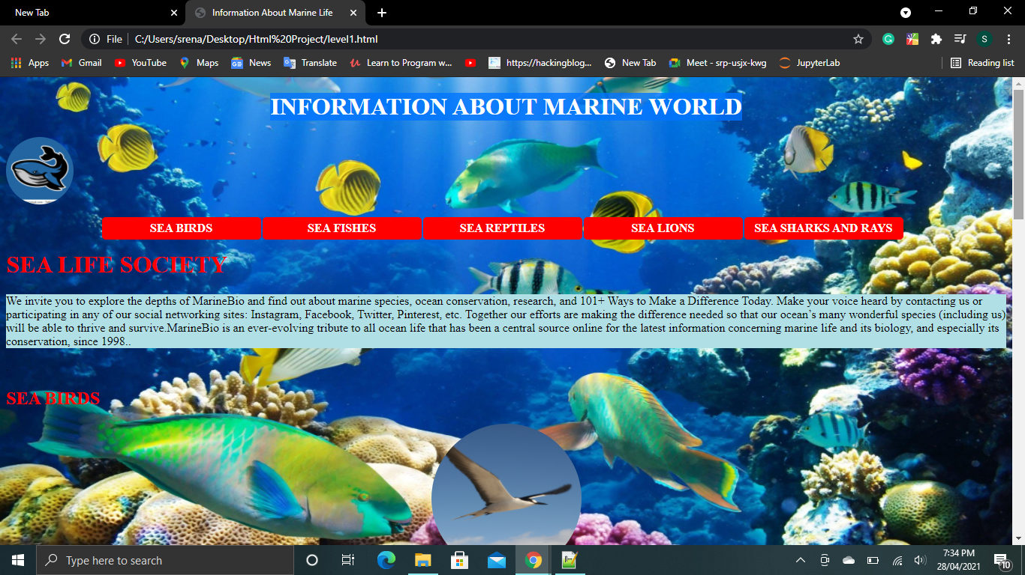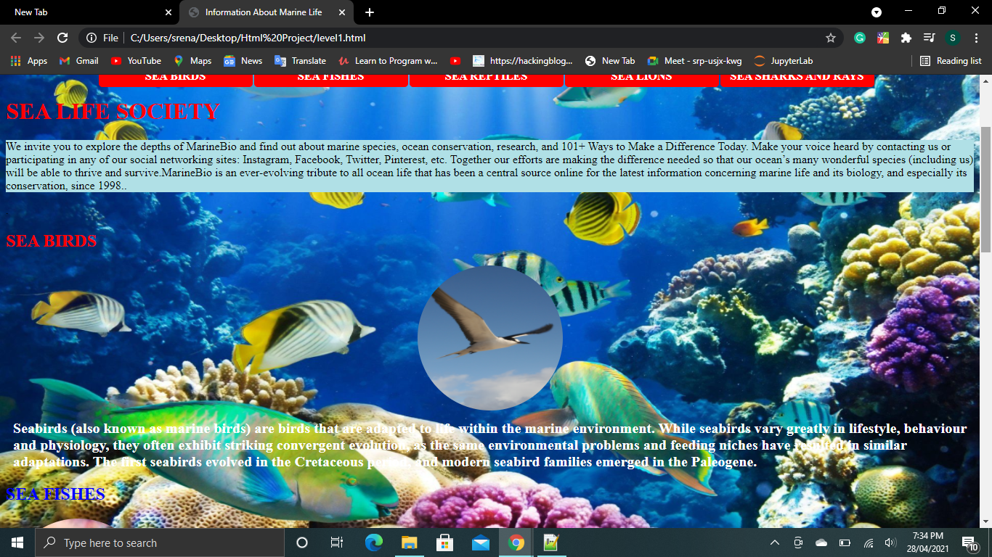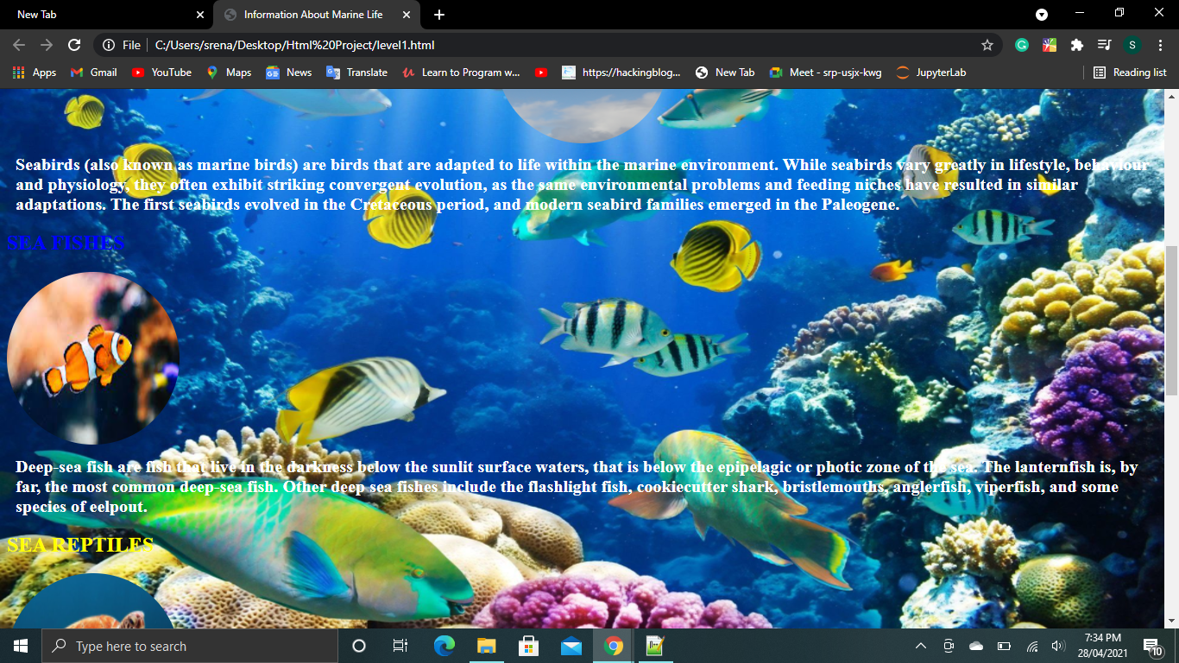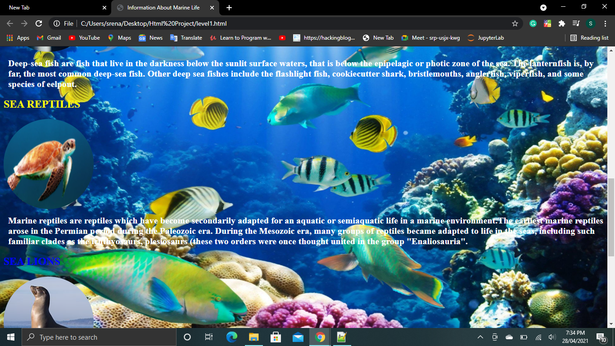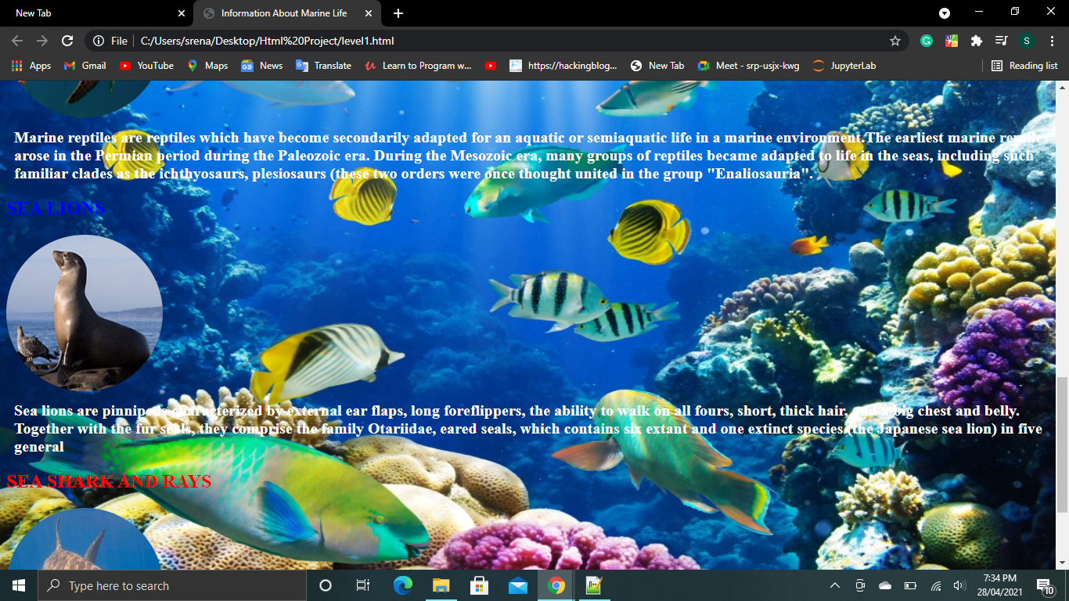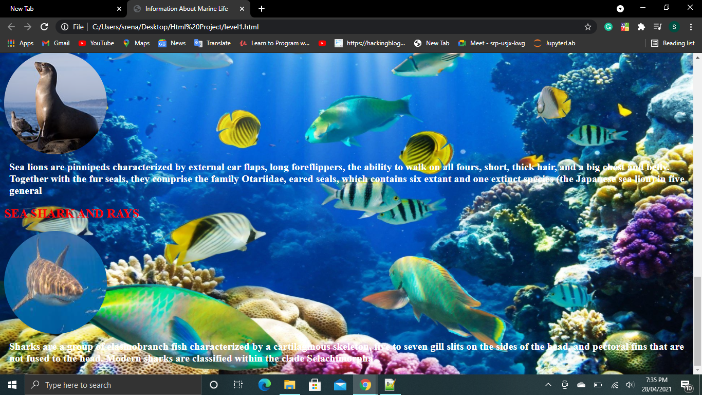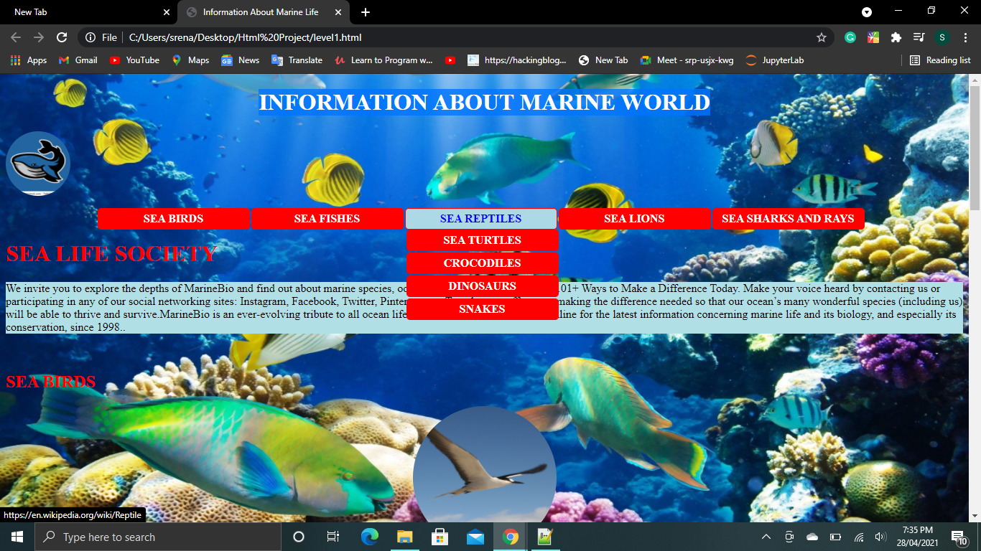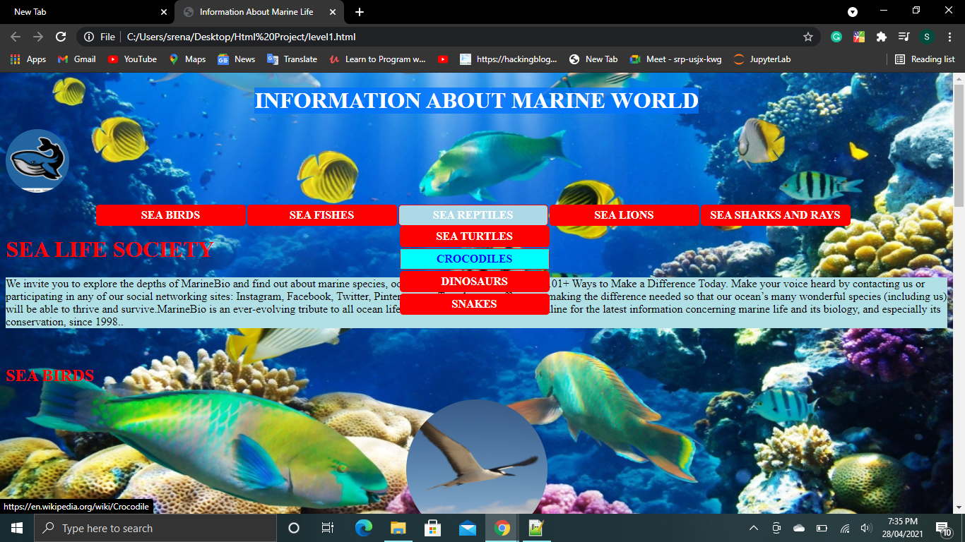

**Level 2 Outputs:**

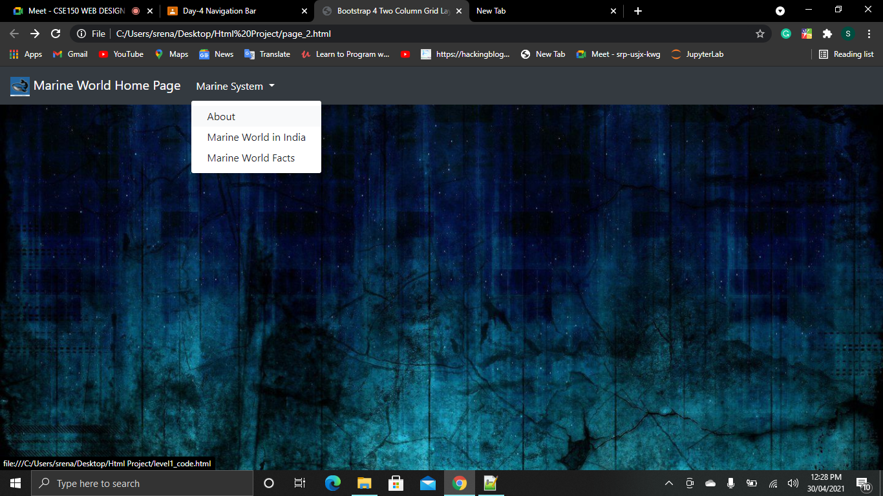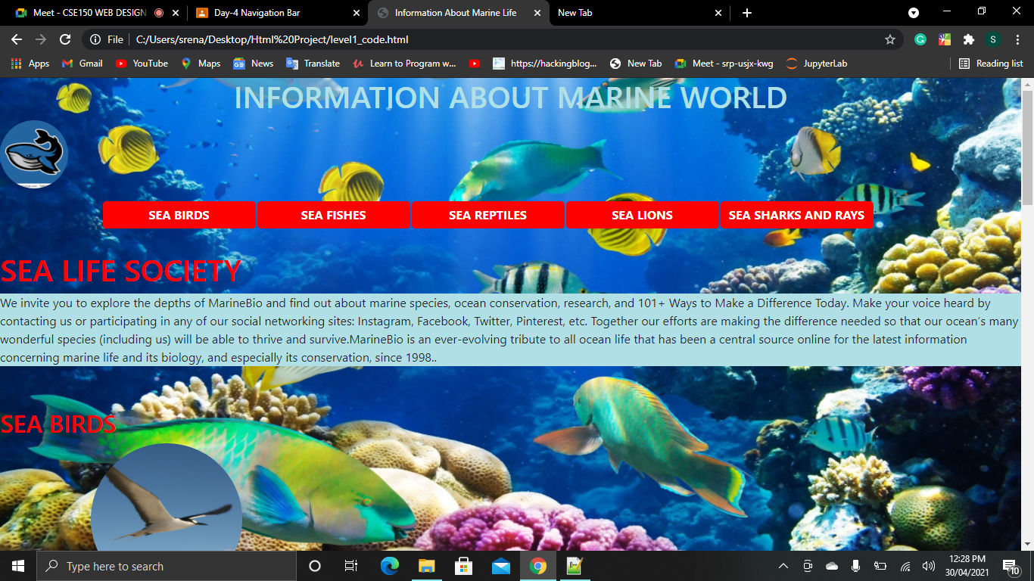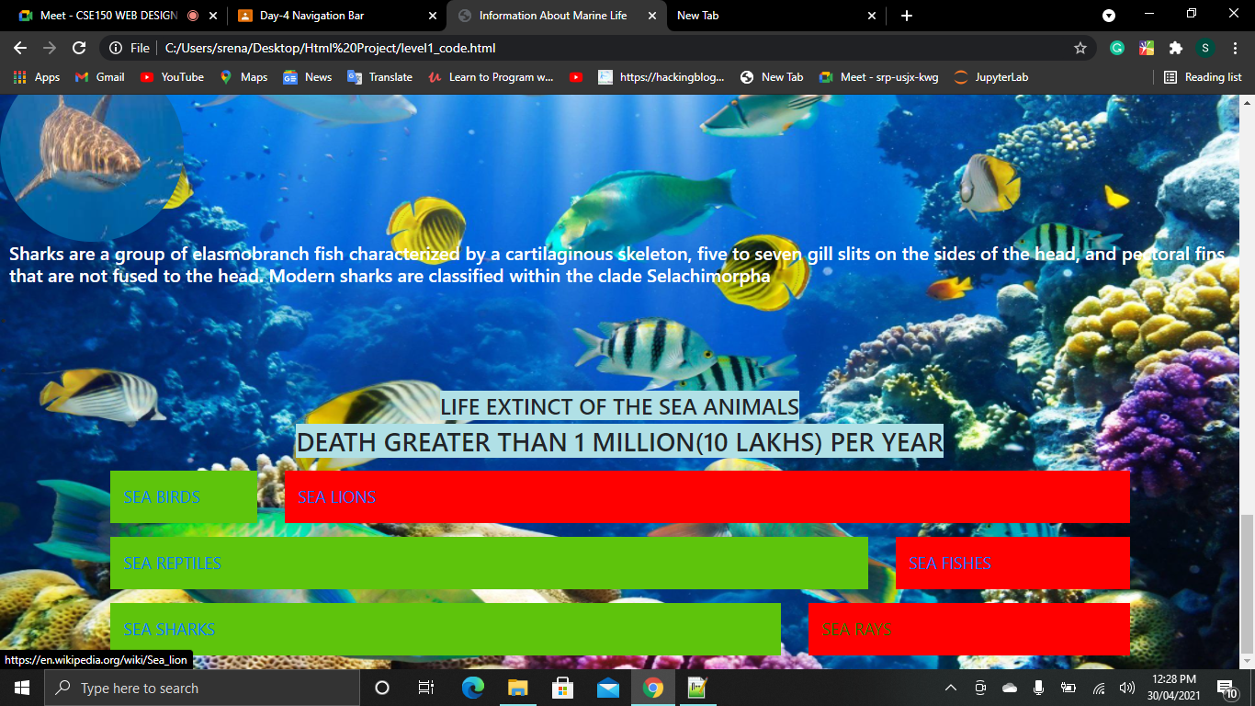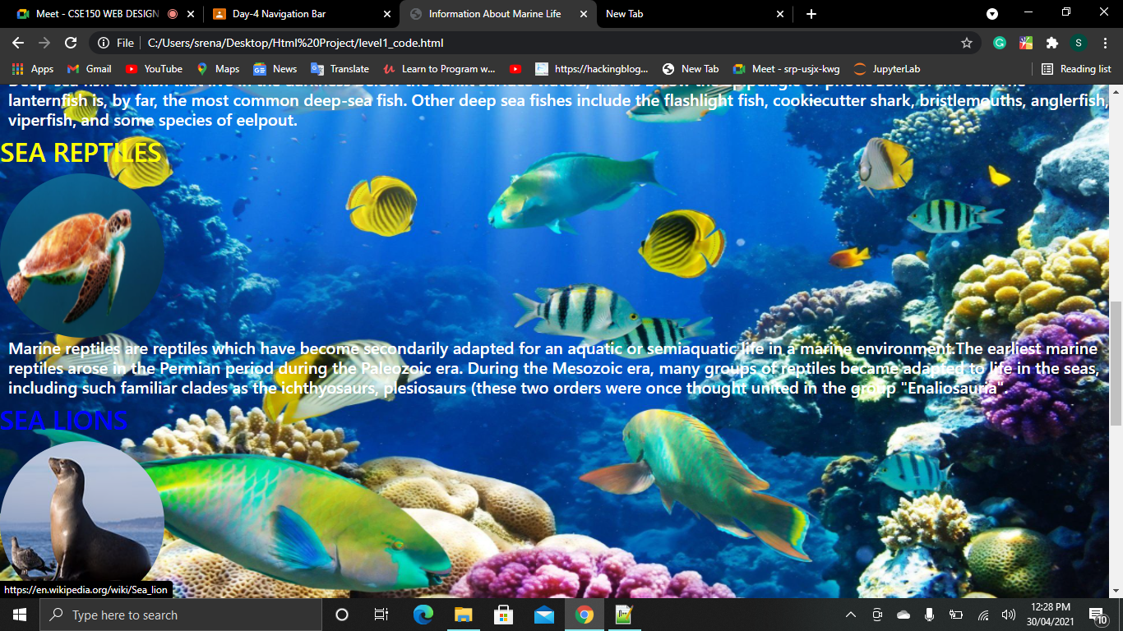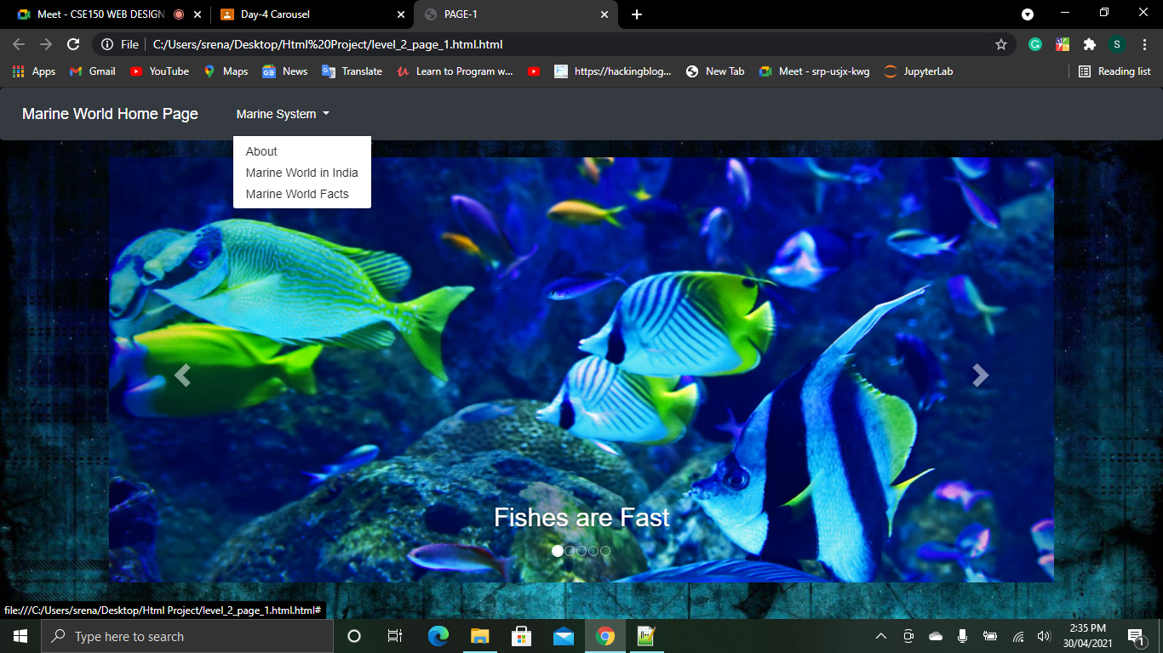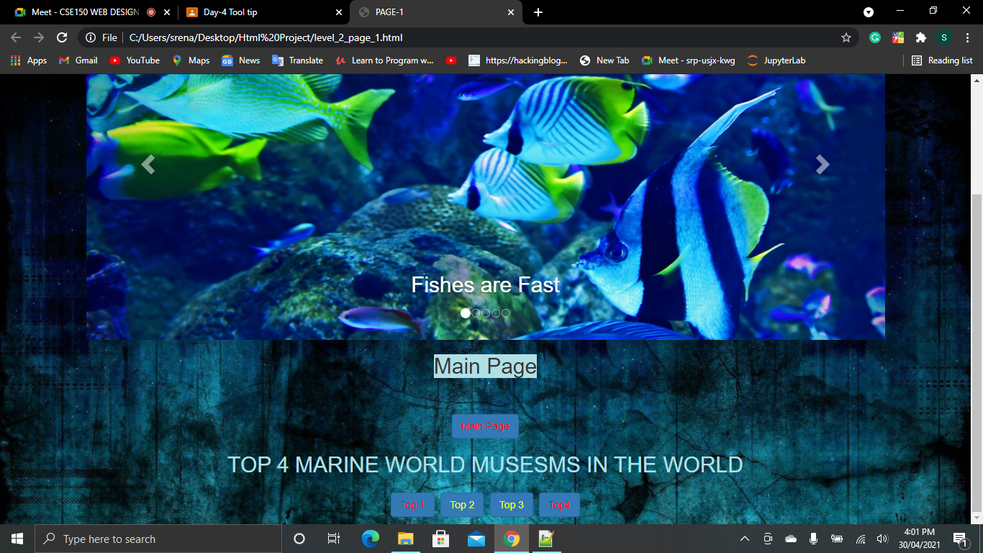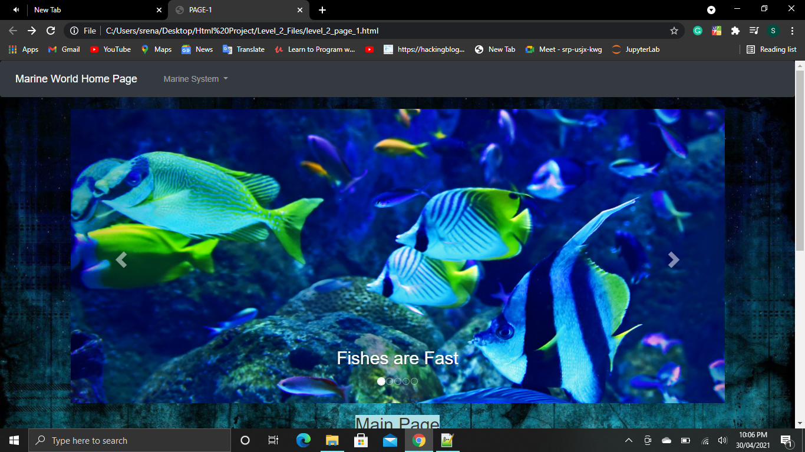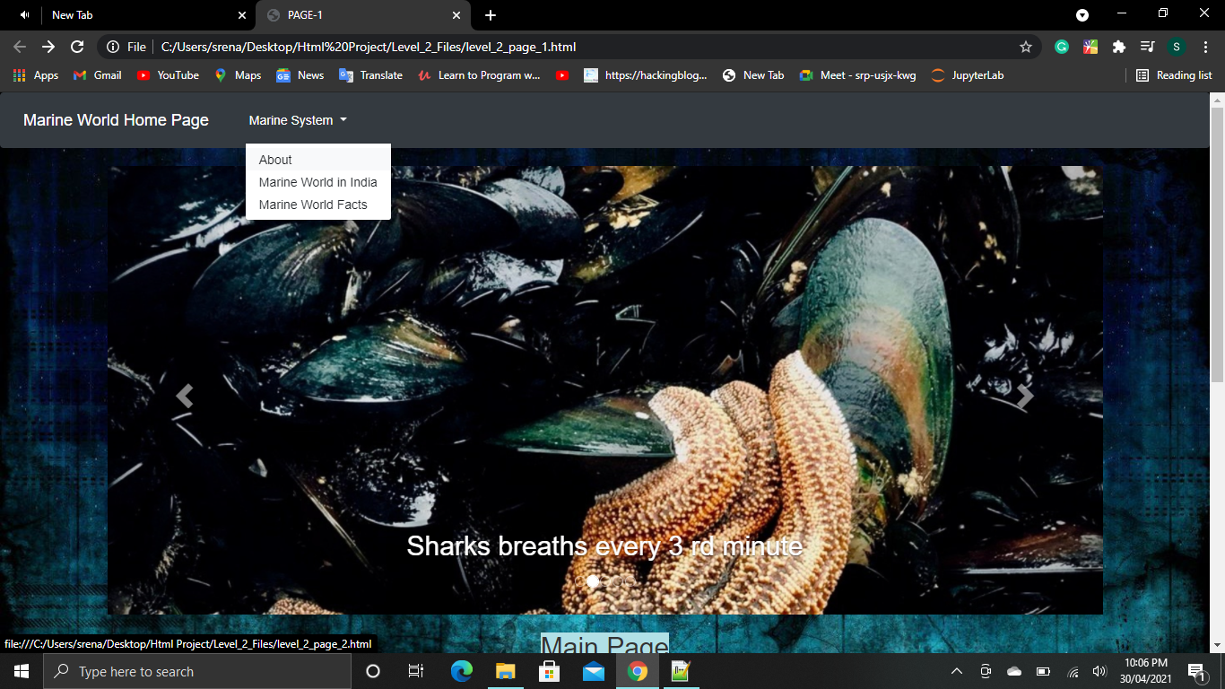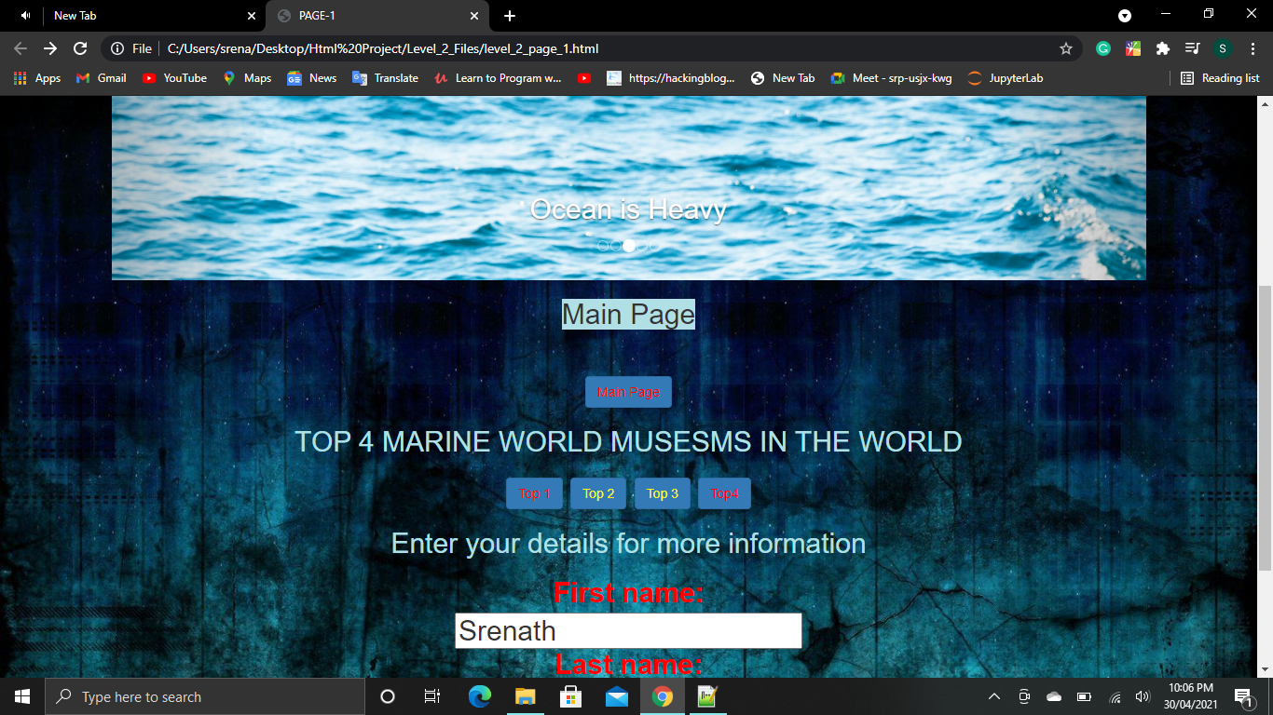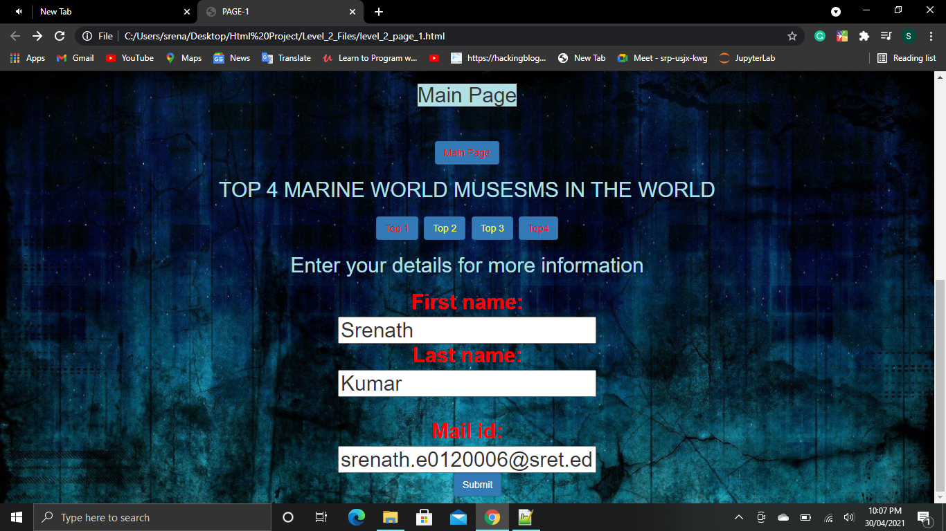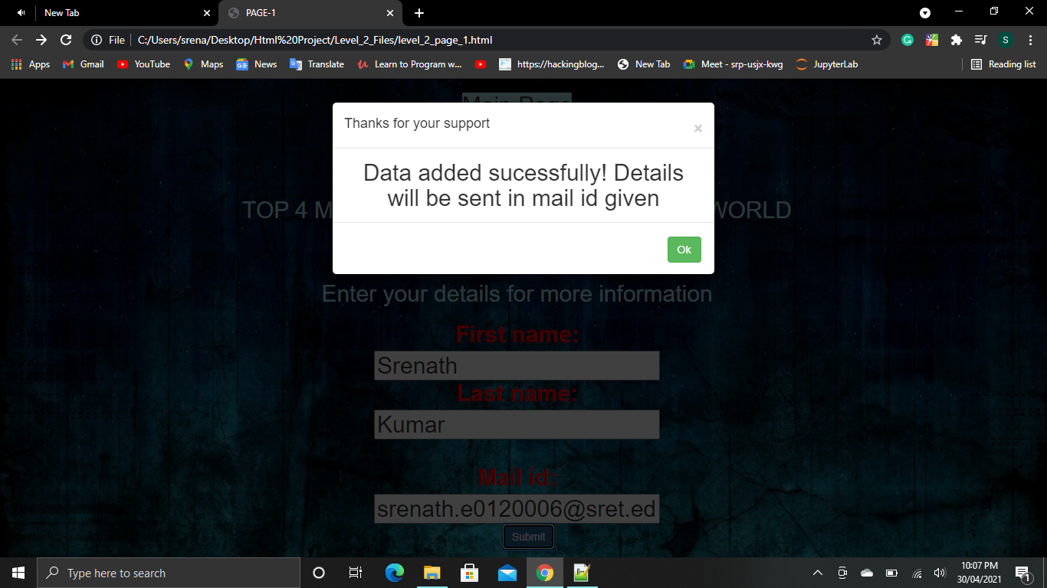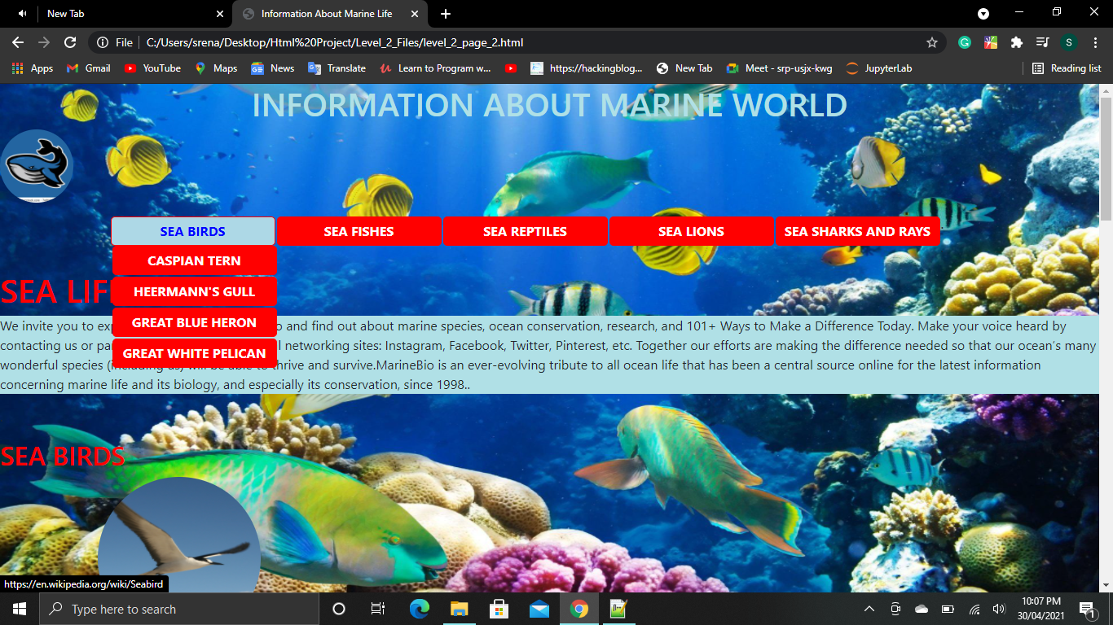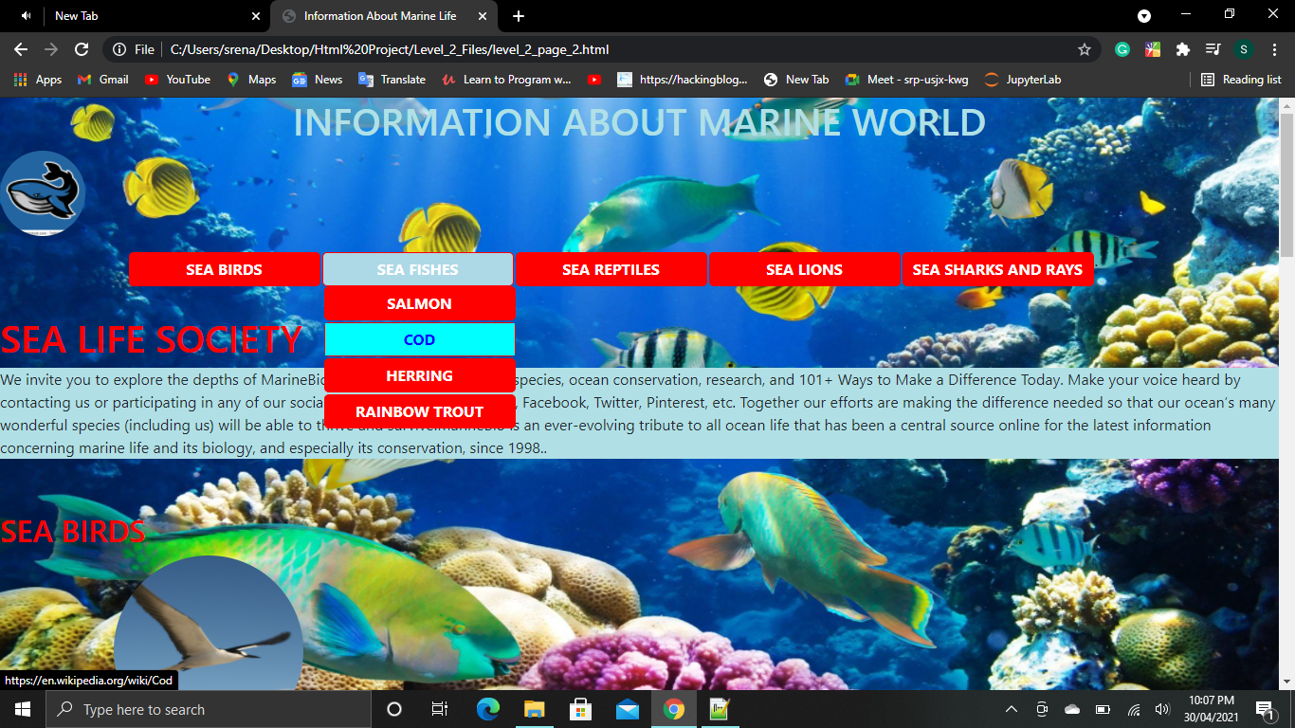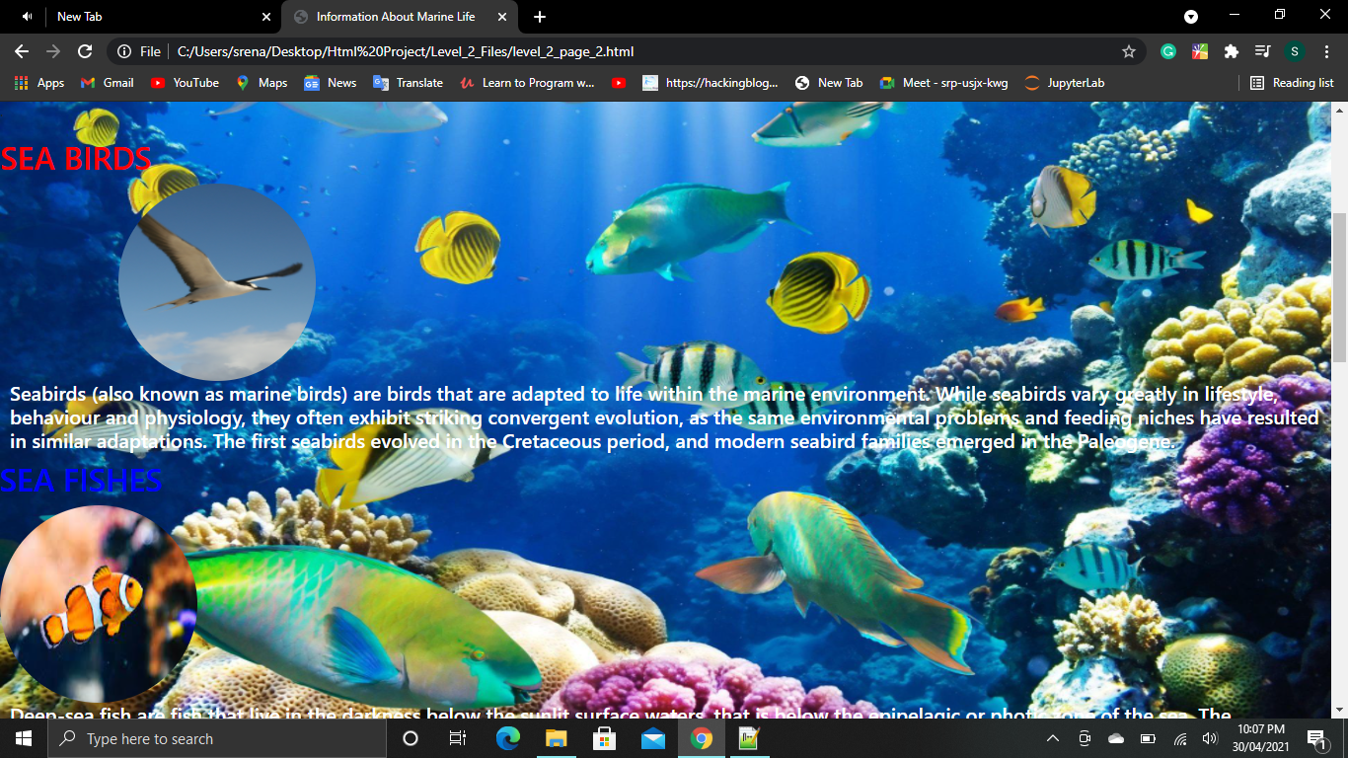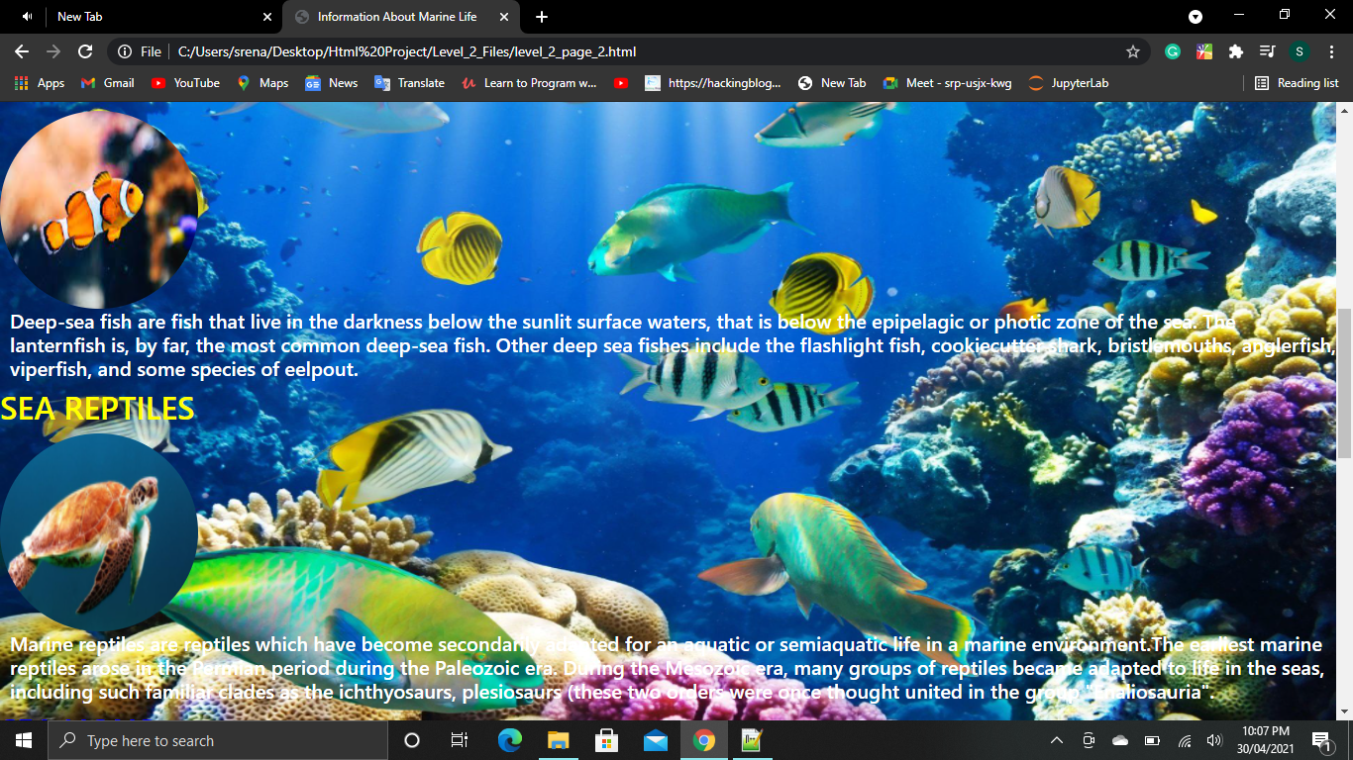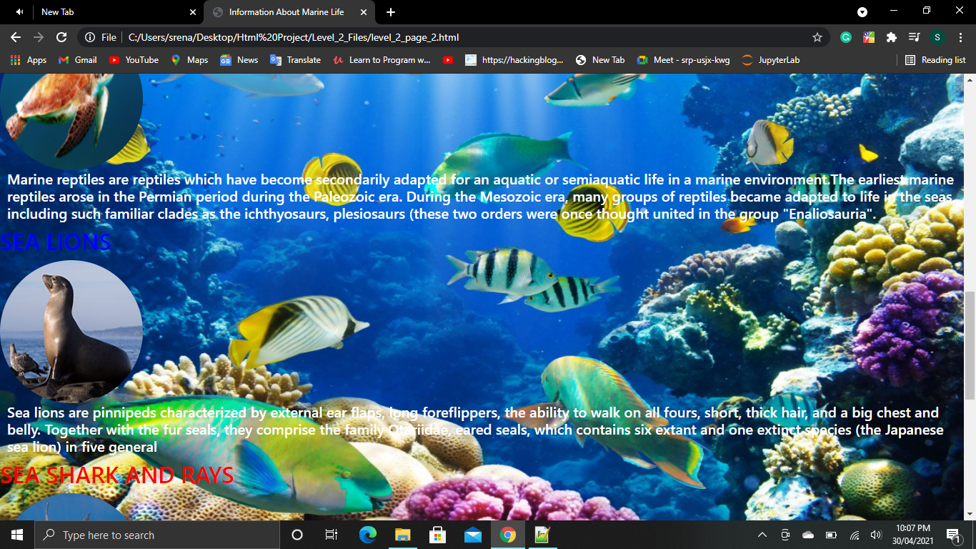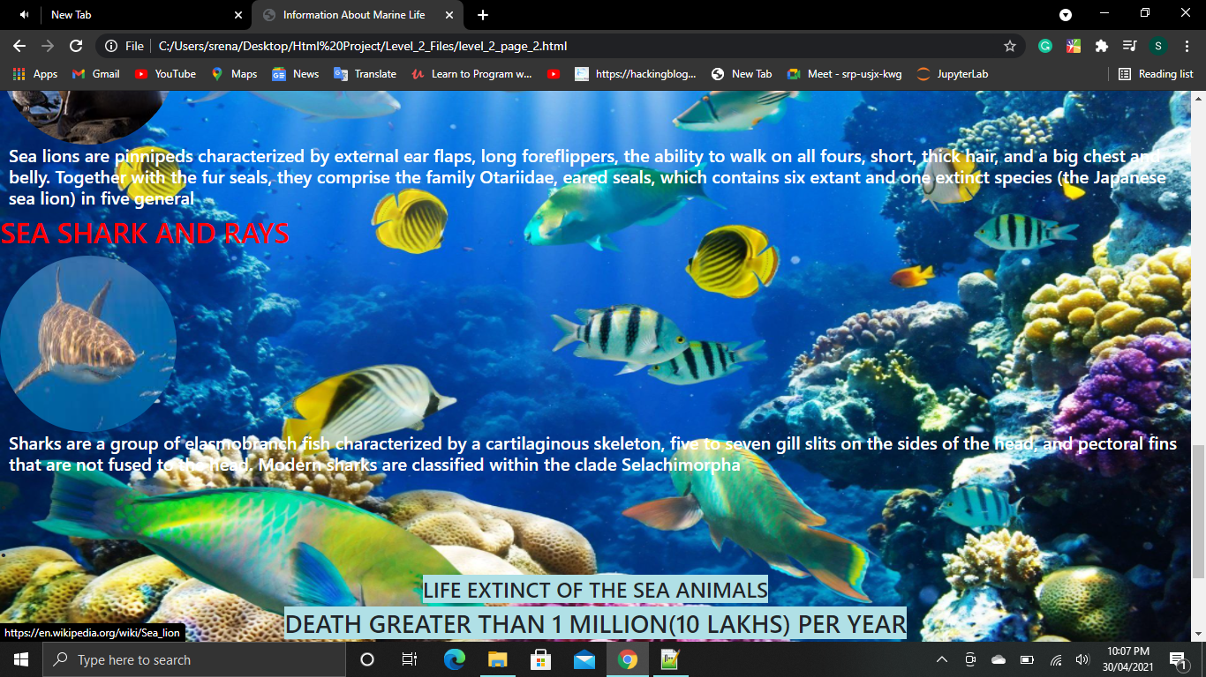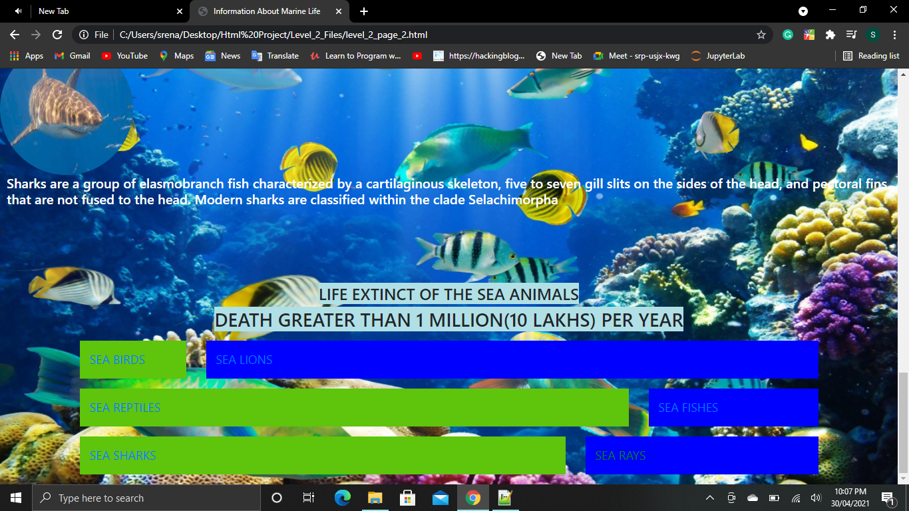

**Level 3-4-5 Code:**

**Softwares Used:**

**Visual Studio Code**

**BootStrap**

**CSS**

**Chrome**

**Component Used are:**

**api**

**binding**

**bindings**

**carousel**

**dolphine**

**fishes**

**footer**

**grid-sytem**

**header**

**home**

**Intro**

**Login**

**login-page**

**Main-navbar**

**nav-drop**

**Pagenotfound**

**Register**

**reset-password**

**reuse**

**routing**

**sharks**

**user**

**File 1 app.component.html**

**<div style="background-image: url('https://www.freecodecamp.org/news/content/images/2020/04/w-qjCHPZbeXCQ-unsplash.jpg');">**

**<br>**

**<app-login-page></app-login-page>**

**File 2 app.component.css**

**table, th, td {**

**border: 1px solid black;**

**border-collapse: collapse;**

**}**

**table.center {**

**margin-left: auto;**

**margin-right: auto;**

**}**

**File 3 app-routing.module.ts**

**import { NgModule } from '@angular/core';**

**import { RouterModule, Routes } from '@angular/router';**

**import { DolphineComponent } from './dolphine/dolphine.component';**

**import { FishesComponent } from './fishes/fishes.component';**

**import { HomeComponent } from './home/home.component';**

**import { LoginComponent } from './login/login.component';**

**import { PagenotfoundComponent } from './pagenotfound/pagenotfound.component';**

**import { RegisterComponent } from './register/register.component';**

**import { ResetPasswordComponent } from './reset-password/reset-password.component';**

**import { SharksComponent } from './sharks/sharks.component';**

**const routes: Routes = [**

**{path: "fishes",component:FishesComponent},**

**{path:"sharks",component:SharksComponent},**

**{path:"dolphine",component:DolphineComponent},**

**{path:"pagenotfound",component:PagenotfoundComponent},**

**{path:'login', component:LoginComponent},**

**{path: 'register', component: RegisterComponent},**

**{path: 'reset-password', component: ResetPasswordComponent},**

**{path: 'home',component:HomeComponent}**

**];**

**@NgModule({**

**imports: [RouterModule.forRoot(routes)],**

**exports: [RouterModule]**

**})**

**export class AppRoutingModule { }**

**export const routingComponents=[FishesComponent,SharksComponent,DolphineComponent,PagenotfoundComponent,LoginComponent,RegisterComponent,ResetPasswordComponent]**

**File 4:app.component.spec.ts**

**import { TestBed } from '@angular/core/testing';**

**import { RouterTestingModule } from '@angular/router/testing';**

**import { AppComponent } from './app.component';**

**describe('AppComponent', () => {**

**beforeEach(async () => {**

**await TestBed.configureTestingModule({**

**imports: [**

**RouterTestingModule**

**],**

**declarations: [**

**AppComponent**

**],**

**}).compileComponents();**

**});**

**it('should create the app', () => {**

**const fixture = TestBed.createComponent(AppComponent);**

**const app = fixture.componentInstance;**

**expect(app).toBeTruthy();**

**});**

**it(`should have as title 'level3'`, () => {**

**const fixture = TestBed.createComponent(AppComponent);**

**const app = fixture.componentInstance;**

**expect(app.title).toEqual('level3');**

**});**

**it('should render title', () => {**

**const fixture = TestBed.createComponent(AppComponent);**

**fixture.detectChanges();**

**const compiled = fixture.nativeElement;**

**expect(compiled.querySelector('.content span').textContent).toContain('level3 app is running!');**

**});**

**});**

**File 5 app.component.ts**

**import { Component } from '@angular/core';**

**@Component({**

**selector: 'app-root',**

**templateUrl: './app.component.html',**

**styleUrls: ['./app.component.css']**

**})**

**export class AppComponent {**

**title = 'level3';**

**mobileinfo = [**

**{**

**name: 'Whales',**

**family:'Selachimorpha',**

**types:"24"},**

**{**

**name:'Dolphins',**

**family:'Delphinidae',**

**types:"45"},**

**{**

**name:'Crocodiles',**

**family:'Crocodylidae',**

**types:'19'**

**},**

**{**

**name:'Turtles',**

**family:'amniotes',**

**types:"25"},**

**{**

**name:'Snakes',**

**family:'Animalia',**

**types:"115"},**

**{**

**name:'Sea Lions',**

**family:'Eared seal',**

**types:"78"},**

**{**

**name:'Rays',**

**family:'Batoidea',**

**types:"156"},**

**]**

**color='darkblue';**

**updateColor()**

**{**

**this.color="black"**

**}**

**image = "https://encrypted-tbn0.gstatic.com/images?q=tbn:ANd9GcSXRacZ6YpMzlZcmAisAfK5DXSz4qiI920QXaINsOABrDujQVTHS-CVErUhq74vPTxPKa8&usqp=CAU";**

**image1="https://encrypted-tbn0.gstatic.com/images?q=tbn:ANd9GcSXRacZ6YpMzlZcmAisAfK5DXSz4qiI920QXaINsOABrDujQVTHS-CVErUhq74vPTxPKa8&usqp=CAU";**

**name="";**

**clickMe(){**

**alert("Data Imported Successfully")**

**}**

**user=[**

**{name:'Fishes',types:39,location:'Maldina tri point'},**

**{name:'Dolphins',types:22,location:'Aldives'},**

**{name:'Sharks',types:30,location:'Australia'}**

**]**

**}**

**File 6 app.module.ts**

**import { NgModule } from '@angular/core';**

**import { BrowserModule } from '@angular/platform-browser';**

**import { FormsModule } from "@angular/forms";**

**import { AppRoutingModule ,routingComponents} from './app-routing.module';**

**import { AppComponent } from './app.component';**

**import { MainNavbarComponent } from './main-navbar/main-navbar.component';**

**import {NgbModule} from "@ng-bootstrap/ng-bootstrap";**

**import { CoursesComponent } from './courses/courses.component';**

**import { ResultsComponent } from './results/results.component';**

**import { NavDropComponent } from './nav-drop/nav-drop.component';**

**import { RoutingComponent } from './routing/routing.component';**

**import { IntroComponent } from './intro/intro.component';**

**import { GridSytemComponent } from './grid-sytem/grid-sytem.component';**

**import { PagenotfoundComponent } from './pagenotfound/pagenotfound.component';**

**import { StructuralDirectiveComponent } from './structural-directive/structural-directive.component';**

**import { StructComponent } from './struct/struct.component';**

**import { CarouselComponent } from './carousel/carousel.component';**

**import { BindingComponent } from './binding/binding.component';**

**import { BindingsComponent } from './bindings/bindings.component';**

**import { UserComponent } from './user/user.component';**

**import { FooterComponent } from './footer/footer.component';**

**import { HeaderComponent } from './header/header.component';**

**import { ReuseComponent } from './reuse/reuse.component';**

**import { LoginComponent } from './login/login.component';**

**import { RegisterComponent } from './register/register.component';**

**import { ResetPasswordComponent } from './reset-password/reset-password.component';**

**import { HomeComponent } from './home/home.component';**

**import { LoginPageComponent } from './login-page/login-page.component';**

**import { ButtonregisterComponent } from './buttonregister/buttonregister.component';**

**import { ApiComponent } from './api/api.component';**

**@NgModule({**

**declarations: [**

**AppComponent,**

**MainNavbarComponent,**

**CoursesComponent,**

**ResultsComponent,**

**NavDropComponent,**

**routingComponents,**

**RoutingComponent,**

**IntroComponent,**

**GridSytemComponent,**

**PagenotfoundComponent,**

**StructuralDirectiveComponent,**

**StructComponent,**

**CarouselComponent,**

**BindingComponent,**

**BindingsComponent,**

**UserComponent,**

**FooterComponent,**

**HeaderComponent,**

**ReuseComponent,**

**LoginComponent,**

**RegisterComponent,**

**ResetPasswordComponent,**

**HomeComponent,**

**LoginPageComponent,**

**ButtonregisterComponent,**

**ApiComponent**

**],**

**imports: [**

**BrowserModule,**

**AppRoutingModule,**

**NgbModule,**

**FormsModule**

**],**

**providers: [],**

**bootstrap: [AppComponent]**

**})**

**export class AppModule { }**

**File 7 api.component.html**

**<form #userPost="ngForm"(ngSubmit)="onSubmit(userPost.value)">**

**<div class="form-group">**

**<label for="username">Username</label>**

**<input**

**id="username"**

**type="text"**

**class="form-control"**

**placeholder="User name">**

**</div>**

**<div class="form-group">**

**<label for="address-user">Address</label>**

**<input**

**id="address-user"**

**type="text"**

**class="form-control"**

**placeholder="Address">**

**</div>**

**<div class="form-group">**

**<label for="email-user">Email</label>**

**<input**

**id="email-user"**

**type="email"**

**class="form-control"**

**placeholder="Email">**

**</div>**

**<div class="form-group">**

**<label for="user-rate">Rating</label>**

**<input**

**id="user-rate"**

**type="text"**

**class="form-control"**

**placeholder="Rating">**

**</div>**

**<button class="btn btn-primary" type="submit">Submit data</button>**

**</form>**

**File 8 app.component.css**

**No data required for output**

**File 9:app.component.spec.ts**

**import { ComponentFixture, TestBed } from '@angular/core/testing';**

**import { ApiComponent } from './api.component';**

**describe('ApiComponent', () => {**

**let component: ApiComponent;**

**let fixture: ComponentFixture<ApiComponent>;**

**beforeEach(async () => {**

**await TestBed.configureTestingModule({**

**declarations: [ ApiComponent ]**

**})**

**.compileComponents();**

**});**

**beforeEach(() => {**

**fixture = TestBed.createComponent(ApiComponent);**

**component = fixture.componentInstance;**

**fixture.detectChanges();**

**});**

**it('should create', () => {**

**expect(component).toBeTruthy();**

**});**

**});**

**File 10 app.component.ts**

**import { Component, OnInit } from '@angular/core';**

**import {HttpClient} from '@angular/common/http';**

**@Component({**

**selector: 'app-api',**

**templateUrl: './api.component.html',**

**styleUrls: ['./api.component.css']**

**})**

**export class ApiComponent implements OnInit {**

**constructor(private http:HttpClient){}**

**onSubmit(data: any)**

**{**

**this.http.post('http://localhost:4200',data)**

**.subscribe((result: any) =>{console.warn("result",result)**

**})**

**console.warn(data);**

**}**

**ngOnInit(): void {**

**}**

**}**

**File 11 binding.component.html**

**<br>**

**<div style="text-align: center;">**

**<h1>Here is Sea Animals Family </h1>**

**<table border="3" class="center">**

**<tr>**

**<th>Sea Animals</th>**

**<th>Family</th>**

**<th>No.of Types</th>**

**</tr>**

**<!---mobileinfor is property, *ngFor fethches the value of the property into table-->**

**<tr *ngFor="let item of mobileinfo">**

**<td [style.color]="color"> {{item.name}}</td>**

**<td [style.color]="color">{{item.family}}</td>**

**<td [style.color]="color">{{item.types}}</td>**

**</tr>**

**</table>**

**<br>**

**<div style="text-align: center;">**

**<button (click)="updateColor()">Update color</button>**

**</div>**

**</div>**

**<!--End-->**

**File 12 binding.component.css**

**table, th, td {**

**border: 1px solid black;**

**border-collapse: collapse;**

**}**

**table.center {**

**margin-left: auto;**

**margin-right: auto;**

**}**

**File 13 binding.component.spec.ts**

**import { ComponentFixture, TestBed } from '@angular/core/testing';**

**import { BindingComponent } from './binding.component';**

**describe('BindingComponent', () => {**

**let component: BindingComponent;**

**let fixture: ComponentFixture<BindingComponent>;**

**beforeEach(async () => {**

**await TestBed.configureTestingModule({**

**declarations: [ BindingComponent ]**

**})**

**.compileComponents();**

**});**

**beforeEach(() => {**

**fixture = TestBed.createComponent(BindingComponent);**

**component = fixture.componentInstance;**

**fixture.detectChanges();**

**});**

**it('should create', () => {**

**expect(component).toBeTruthy();**

**});**

**});**

**File 14 binding.component.ts**

**import { Component, OnInit } from '@angular/core';**

**@Component({**

**selector: 'app-binding',**

**templateUrl: './binding.component.html',**

**styleUrls: ['./binding.component.css']**

**})**

**export class BindingComponent implements OnInit {**

**constructor() { }**

**ngOnInit(): void {**

**}**

**mobileinfo = [**

**{**

**name: 'Whales',**

**family:'Selachimorpha',**

**types:"24"},**

**{**

**name:'Dolphins',**

**family:'Delphinidae',**

**types:"45"},**

**{**

**name:'Crocodiles',**

**family:'Crocodylidae',**

**types:'19'**

**},**

**{**

**name:'Turtles',**

**family:'amniotes',**

**types:"25"},**

**{**

**name:'Snakes',**

**family:'Animalia',**

**types:"115"},**

**{**

**name:'Sea Lions',**

**family:'Eared seal',**

**types:"78"},**

**{**

**name:'Rays',**

**family:'Batoidea',**

**types:"156"},**

**]**

**color='darkblue';**

**updateColor()**

**{**

**this.color="red"**

**}**

**}**

**File 15 bindings.component.html**

**<div style="text-align: center;">**

**<h2>Enter your details for more information</h2>**

**<label>Email-id:**

**<input [(ngModel)]="name">**

**</label>**

**<br>**

**<h2>Email-id:{{name}}</h2>**

**<div>**

**<button class="btn-medium" (click)="clickMe()">Enter </button>**

**</div>**

**</div>**

**File 16 bindings.component.css**

**No data required for the output**

**File 17 bindings.component.spec.ts**

**import { ComponentFixture, TestBed } from '@angular/core/testing';**

**import { BindingsComponent } from './bindings.component';**

**describe('BindingsComponent', () => {**

**let component: BindingsComponent;**

**let fixture: ComponentFixture<BindingsComponent>;**

**beforeEach(async () => {**

**await TestBed.configureTestingModule({**

**declarations: [ BindingsComponent ]**

**})**

**.compileComponents();**

**});**

**beforeEach(() => {**

**fixture = TestBed.createComponent(BindingsComponent);**

**component = fixture.componentInstance;**

**fixture.detectChanges();**

**});**

**it('should create', () => {**

**expect(component).toBeTruthy();**

**});**

**});**

**File 18 bindings.component.ts**

**import { Component, OnInit } from '@angular/core';**

**@Component({**

**selector: 'app-bindings',**

**templateUrl: './bindings.component.html',**

**styleUrls: ['./bindings.component.css']**

**})**

**export class BindingsComponent implements OnInit {**

**constructor() { }**

**ngOnInit(): void {**

**}**

**image = "https://encrypted-tbn0.gstatic.com/images?q=tbn:ANd9GcSXRacZ6YpMzlZcmAisAfK5DXSz4qiI920QXaINsOABrDujQVTHS-CVErUhq74vPTxPKa8&usqp=CAU";**

**image1="https://encrypted-tbn0.gstatic.com/images?q=tbn:ANd9GcSXRacZ6YpMzlZcmAisAfK5DXSz4qiI920QXaINsOABrDujQVTHS-CVErUhq74vPTxPKa8&usqp=CAU";**

**name="";**

**clickMe(){**

**alert("Data Imported Successfully.Details will be sent shortly")**

**}**

**}**

**File 19 carousel.component.html**

**<link rel="stylesheet" href="https://maxcdn.bootstrapcdn.com/bootstrap/3.4.1/css/bootstrap.min.css">**

**<div class="container">**

**<div id="myCarousel" class="carousel slide" data-ride="carousel">**

**<!-- Indicators -->**

**<ol class="carousel-indicators">**

**<li data-target="#myCarousel" data-slide-to="0" class="active"></li>**

**<li data-target="#myCarousel" data-slide-to="1"></li>**

**<li data-target="#myCarousel" data-slide-to="2"></li>**

**</ol>**

**<!-- Wrapper for slides -->**

**<div class="carousel-inner">**

**<div class="item active">**

**<img src="https://www.homestratosphere.com/wp-content/uploads/2019/03/1-5-3-1.jpg" alt="Fishes" style="width:100%;">**

**<div class="carousel-caption">**

**<h3>Fishes</h3>**

**<p>Fishes takes oxygen every 10 th second</p>**

**</div>**

**</div>**

**<div class="item">**

**<img src="https://cdn.britannica.com/s:800x450,c:crop/66/195966-138-F9E7A828/facts-turtles.jpg" alt="Turtles" style="width:100%;">**

**<div class="carousel-caption">**

**<h3>Turtles</h3>**

**<p>Turtles lives in both land and water</p>**

**</div>**

**</div>**

**<div class="item">**

**<img src="https://static.dw.com/image/15943674_303.jpg" alt="Dolphins" style="width:100%;">**

**<div class="carousel-caption">**

**<h3>Dolphins</h3>**

**<p>Dolphins jumps at the height of 10 feet</p>**

**</div>**

**</div>**

**</div>**

**<!-- Left and right controls -->**

**<a class="left carousel-control" href="#myCarousel" data-slide="prev">**

**<span class="glyphicon glyphicon-chevron-left"></span>**

**<span class="sr-only">Previous</span>**

**</a>**

**<a class="right carousel-control" href="#myCarousel" data-slide="next">**

**<span class="glyphicon glyphicon-chevron-right"></span>**

**<span class="sr-only">Next</span>**

**</a>**

**</div>**

**</div>**

**File 20 carousel.component.css**

**.demo-content{**

**padding: 40px;**

**font-size: 40px;**

**background: #aadfe5;**

**margin-bottom: 40px;**

**}**

**.demo-content.bg-alt{**

**background: #adb1b8;**

**}**

**.carousel-inner > .item {**

**height: 500px;**

**}**

**content{**

**padding: 15px;**

**font-size: 18px;**

**background: #ceb3ad;**

**margin-bottom: 15px;**

**}**

**.content.bg-alt{**

**background: #cddadb;**

**}**

**h2 {**

**text-align: center;**

**}**

**File 21 carousel.component.spec.ts**

**import { ComponentFixture, TestBed } from '@angular/core/testing';**

**import { CarouselComponent } from './carousel.component';**

**describe('CarouselComponent', () => {**

**let component: CarouselComponent;**

**let fixture: ComponentFixture<CarouselComponent>;**

**beforeEach(async () => {**

**await TestBed.configureTestingModule({**

**declarations: [ CarouselComponent ]**

**})**

**.compileComponents();**

**});**

**beforeEach(() => {**

**fixture = TestBed.createComponent(CarouselComponent);**

**component = fixture.componentInstance;**

**fixture.detectChanges();**

**});**

**it('should create', () => {**

**expect(component).toBeTruthy();**

**});**

**});**

**File 22 carousel.component.ts**

**import { Component, OnInit } from '@angular/core';**

**@Component({**

**selector: 'carousel',**

**templateUrl: './carousel.component.html',**

**styleUrls: ['./carousel.component.css']**

**})**

**export class CarouselComponent implements OnInit {**

**constructor() { }**

**ngOnInit(): void {**

**}**

**}**

**File 23 dolphine.component.html**

**<br>**

**<br>**

**<h2 style="text-align:center;" ><span style="color: red">DOLPHINS</span></h2>**

**<div style="text-align: center;">**

**<img src="https://images2.minutemediacdn.com/image/upload/c_crop,h_1778,w_3155,x_0,y_843/v1554928552/shape/mentalfloss/540093-istock-514343279.jpg?itok=isS-TJcM" alt="https://en.wikipedia.org/wiki/Sea_lion" style="width:250px">**

**</div>**

**<p style="text-align:center">Dolphin is the common name of aquatic mammals within**

**the infraorder Cetacea. The term dolphin usually refers to the extant families Delphinidae**

**(the oceanic dolphins), Platanistidae (the Indian river dolphins), named Iniidae (the New**

**World river dolphins), and Pontoporiidae (the brackish dolphins), and the extinct Lipotidae**

**(baiji or Chinese river dolphin). There are 40 extant species named as dolphins.**

**Dolphins can range in size from the relatively small 1.7-metre-long (5 ft 7 in) long**

**and 50-kilogram (110-pound) bodied Maui's dolphin to the 9.5 m (31 ft 2 in) and 10-tonne**

**(11-short-ton) killer whale. Several species exhibit sexual dimorphism, in that the males**

**are larger than females. They have streamlined bodies and two limbs that are modified into**

**flippers. Though not quite as flexible as seals, some dolphins can travel at speeds 29 km/h**

**(18 mph) for short distances. Dolphins use their conical shaped teeth to capture fast moving**

**prey. They have well-developed hearing which is adapted for both air and water and is so well**

**developed that some can survive even if they are blind. Some species are well adapted for diving**

**to great depths. They have a layer of fat, or blubber, under the skin to keep warm in the cold**

**water.</p>**

**File 24 dolphine.component.css**

**img {**

**border-radius: 60%;**

**}**

**File 25 dolphine.component.spec.ts**

**import { ComponentFixture, TestBed } from '@angular/core/testing';**

**import { DolphineComponent } from './dolphine.component';**

**describe('DolphineComponent', () => {**

**let component: DolphineComponent;**

**let fixture: ComponentFixture<DolphineComponent>;**

**beforeEach(async () => {**

**await TestBed.configureTestingModule({**

**declarations: [ DolphineComponent ]**

**})**

**.compileComponents();**

**});**

**beforeEach(() => {**

**fixture = TestBed.createComponent(DolphineComponent);**

**component = fixture.componentInstance;**

**fixture.detectChanges();**

**});**

**it('should create', () => {**

**expect(component).toBeTruthy();**

**});**

**});**

**File 26 dolphine.component.ts**

**import { Component, OnInit } from '@angular/core';**

**@Component({**

**selector: 'app-dolphine',**

**templateUrl: './dolphine.component.html',**

**styleUrls: ['./dolphine.component.css']**

**})**

**export class DolphineComponent implements OnInit {**

**constructor() { }**

**ngOnInit(): void {**

**}**

**}**

**File 27 fishes.component.html**

**<br>**

**<br>**

**<h2 style="text-align:center;" ><span style="color: green">FISHES</span></h2>**

**<div style="text-align: center;">**

**<img src="https://images.unsplash.com/photo-1535591273668-578e31182c4f?ixlib=rb-1.2.1&q=80&fm=jpg&crop=entropy&cs=tinysrgb&w=1080&fit=max&ixid=eyJhcHBfaWQiOjM2NTI5fQ" alt="https://en.wikipedia.org/wiki/Sea_lion" style="width:250px">**

**</div>**

**<p style="text-align:center">Fish are aquatic, craniate, gill-bearing animals that lack limbs**

**with digits. They form a sister group to the tunicates, together forming the olfactores. Included**

**in this definition are the living hagfish, lampreys, and cartilaginous and bony fish as well as**

**various extinct related groups. Around 99% of living fish species are ray-finned fish, belonging**

**to the class Actinopterygii, with over 95% belonging to the teleost subgrouping.**

**The earliest organisms that can be classified as fish were soft-bodied chordates that first**

**appeared during the Cambrian period. Although they lacked a true spine, they possessed notochords**

**which allowed them to be more agile than their invertebrate counterparts. Fish would continue to**

**evolve through the Paleozoic era, diversifying into a wide variety of forms. Many fish of the**

**Paleozoic developed external armor that protected them from predators. The first fish with jaws**

**appeared in the Silurian period, after which many (such as sharks) became formidable marine predators**

**rather than just the prey of arthropods.</p>**

**File 28 fishes.component.css**

**img {**

**border-radius: 60%;**

**}**

**File 29 fishes.component.spec.ts**

**import { ComponentFixture, TestBed } from '@angular/core/testing';**

**import { FishesComponent } from './fishes.component';**

**describe('FishesComponent', () => {**

**let component: FishesComponent;**

**let fixture: ComponentFixture<FishesComponent>;**

**beforeEach(async () => {**

**await TestBed.configureTestingModule({**

**declarations: [ FishesComponent ]**

**})**

**.compileComponents();**

**});**

**beforeEach(() => {**

**fixture = TestBed.createComponent(FishesComponent);**

**component = fixture.componentInstance;**

**fixture.detectChanges();**

**});**

**it('should create', () => {**

**expect(component).toBeTruthy();**

**});**

**});**

**File 30 fishes.component.ts**

**import { Component, OnInit } from '@angular/core';**

**@Component({**

**selector: 'app-fishes',**

**templateUrl: './fishes.component.html',**

**styleUrls: ['./fishes.component.css']**

**})**

**export class FishesComponent implements OnInit {**

**constructor() { }**

**ngOnInit(): void {**

**}**

**}**

**File 31 grid-sytem.component.html**

**<h2 class="text-center my-3">LIFE EXTINCT OF THE SEA ANIMALS</h2>**

**<div class="text-center">DEATH GREATER THAN 1 MILLION(10 LAKHS) PER YEAR</div>**

**<div class="container mt-3">**

**<div class="row">**

**<div class="col-8 bg-success">FISHES:60%</div>**

**<div class="col-4 bg-warning">LD Ratio:6:4</div>**

**</div>**

**<br>**

**<div class="row">**

**<div class="col-3 bg-success">SHARKS:40%</div>**

**<div class="col-9 bg-warning">LD Ratio:7:3</div>**

**</div>**

**<br>**

**<div class="row">**

**<div class="col-7 bg-success">DOLPHINS=65%</div>**

**<div class="col-5 bg-warning">LD Ratio:7:3</div>**

**</div>**

**<br>**

**<div class="row">**

**<div class="col-3 bg-success">REPTILES=23%</div>**

**<div class="col-9 bg-warning">LD Ratio:5:5</div>**

**</div>**

**</div>**

**File 32 grid-sytem.component.css**

**.content{**

**padding: 15px;**

**font-size: 18px;**

**background: #5ec40c;**

**margin-bottom: 15px;**

**}**

**File 33 grid-sytem.component.spec.ts**

**import { ComponentFixture, TestBed } from '@angular/core/testing';**

**import { GridSytemComponent } from './grid-sytem.component';**

**describe('GridSytemComponent', () => {**

**let component: GridSytemComponent;**

**let fixture: ComponentFixture<GridSytemComponent>;**

**beforeEach(async () => {**

**await TestBed.configureTestingModule({**

**declarations: [ GridSytemComponent ]**

**})**

**.compileComponents();**

**});**

**beforeEach(() => {**

**fixture = TestBed.createComponent(GridSytemComponent);**

**component = fixture.componentInstance;**

**fixture.detectChanges();**

**});**

**it('should create', () => {**

**expect(component).toBeTruthy();**

**});**

**});**

**File 34 grid-sytem.component.ts**

**import { Component, OnInit } from '@angular/core';**

**@Component({**

**selector: 'grid-sytem',**

**templateUrl: './grid-sytem.component.html',**

**styleUrls: ['./grid-sytem.component.css']**

**})**

**export class GridSytemComponent implements OnInit {**

**constructor() { }**

**ngOnInit(): void {**

**}**

**}**

**File 35 header.component.html**

**<h3>Welcome to Marine World</h3>**

**File 36 header.component.css**

**h3{**

**background-color: rgb(14, 171, 223);**

**margin: 0;**

**padding: 15px;**

**text-align: center;**

**}**

**File 37 header.component.spec.ts**

**import { ComponentFixture, TestBed } from '@angular/core/testing';**

**import { HeaderComponent } from './header.component';**

**describe('HeaderComponent', () => {**

**let component: HeaderComponent;**

**let fixture: ComponentFixture<HeaderComponent>;**

**beforeEach(async () => {**

**await TestBed.configureTestingModule({**

**declarations: [ HeaderComponent ]**

**})**

**.compileComponents();**

**});**

**beforeEach(() => {**

**fixture = TestBed.createComponent(HeaderComponent);**

**component = fixture.componentInstance;**

**fixture.detectChanges();**

**});**

**it('should create', () => {**

**expect(component).toBeTruthy();**

**});**

**});**

**File 38 header.component.ts**

**import { Component, OnInit } from '@angular/core';**

**@Component({**

**selector: 'app-header',**

**templateUrl: './header.component.html',**

**styleUrls: ['./header.component.css']**

**})**

**export class HeaderComponent implements OnInit {**

**constructor() { }**

**ngOnInit(): void {**

**}**

**}**

**File 39 home.component.html**

**<app-header></app-header>**

**<carousel></carousel>**

**<intro></intro>**

**<grid-sytem></grid-sytem>**

**<app-binding></app-binding>**

**<app-reuse></app-reuse>**

**<app-bindings></app-bindings>**

**<routing></routing>**

**File 40 home.component.css**

**NO data required for the output**

**File 41 home.component.spec.ts**

**import { ComponentFixture, TestBed } from '@angular/core/testing';**

**import { HomeComponent } from './home.component';**

**describe('HomeComponent', () => {**

**let component: HomeComponent;**

**let fixture: ComponentFixture<HomeComponent>;**

**beforeEach(async () => {**

**await TestBed.configureTestingModule({**

**declarations: [ HomeComponent ]**

**})**

**.compileComponents();**

**});**

**beforeEach(() => {**

**fixture = TestBed.createComponent(HomeComponent);**

**component = fixture.componentInstance;**

**fixture.detectChanges();**

**});**

**it('should create', () => {**

**expect(component).toBeTruthy();**

**});**

**});**

**File 42 home.component.ts**

**import { Component, OnInit } from '@angular/core';**

**@Component({**

**selector: 'app-home',**

**templateUrl: './home.component.html',**

**styleUrls: ['./home.component.css']**

**})**

**export class HomeComponent implements OnInit {**

**constructor() { }**

**ngOnInit(): void {**

**}**

**}**

**File 43 inro.component.html**

**<br>**

**<h1 style="text-align:center;" ><span style="color: powderblue">MARINE WORLD</span></h1>**

**<nav-drop></nav-drop>**

**<br>**

**<br>**

**<h3 style="text-align:center;" ><span style="color: rgb(51, 255, 0)">SEA LIFE SOCIETY</span></h3>**

**<p style="background-color:powderblue;">We invite you to explore the depths of MarineBio and find out about marine species, ocean conservation, research,**

**and 101+ Ways to Make a Difference Today. Make your voice heard by contacting us or participating in any of our social**

**networking sites: Instagram, Facebook, Twitter, Pinterest, etc. Together our efforts are making the difference needed so**

**that our ocean’s many wonderful species (including us) will be able to thrive and survive.MarineBio is an ever-evolving**

**tribute to all ocean life that has been a central source online for the latest information concerning marine life and its**

**biology, and especially its conservation, since 1998..</p>**

**File 44 intro.component.css**

**No data required for the output**

**File 45 intro.component.spec.ts**

**import { ComponentFixture, TestBed } from '@angular/core/testing';**

**import { IntroComponent } from './intro.component';**

**describe('IntroComponent', () => {**

**let component: IntroComponent;**

**let fixture: ComponentFixture<IntroComponent>;**

**beforeEach(async () => {**

**await TestBed.configureTestingModule({**

**declarations: [ IntroComponent ]**

**})**

**.compileComponents();**

**});**

**beforeEach(() => {**

**fixture = TestBed.createComponent(IntroComponent);**

**component = fixture.componentInstance;**

**fixture.detectChanges();**

**});**

**it('should create', () => {**

**expect(component).toBeTruthy();**

**});**

**});**

**File 46 intro.component.ts**

**import { Component, OnInit } from '@angular/core';**

**@Component({**

**selector: 'intro',**

**templateUrl: './intro.component.html',**

**styleUrls: ['./intro.component.css']**

**})**

**export class IntroComponent implements OnInit {**

**constructor() { }**

**ngOnInit(): void {**

**}**

**}**

**File 47 login.component.html**

**<br>**

**<app-header></app-header>**

**<div style="text-align: center;">**

**<div class="container">**

**<div class="col-md-6 offset-md mt-4">**

**<h3>Login </h3>**

**<form>**

**<form>**

**<div class="form-group">**

**<label for="loginusername">Username</label>**

**<input type="text"**

**class="form-control"**

**id="loginusername"**

**placeholder="Enter Username">**

**</div>**

**<div class="form-group">**

**<label for="LoginPassword">Password</label>**

**<input type="password"**

**class="form-control"**

**id="LoginPassword"**

**placeholder="Password">**

**</div>**

**<div class="form-group form-check">**

**<a [routerLink]="['/reset-password']"> Forgot Password </a>**

**</div>**

**<a [routerLink]="['/home']">**

**<button type="submit" class="btn btn-primary">Login <i class="fas fa-sign-in-alt"></i></button>**

**</a>**

**</form>**

**</form>**

**</div>**

**</div>**

**</div>**

**File 48 login.component.css**

**NO data Required for the output**

**File 49 login.component.spec.ts**

**import { ComponentFixture, TestBed } from '@angular/core/testing';**

**import { LoginComponent } from './login.component';**

**describe('LoginComponent', () => {**

**let component: LoginComponent;**

**let fixture: ComponentFixture<LoginComponent>;**

**beforeEach(async () => {**

**await TestBed.configureTestingModule({**

**declarations: [ LoginComponent ]**

**})**

**.compileComponents();**

**});**

**beforeEach(() => {**

**fixture = TestBed.createComponent(LoginComponent);**

**component = fixture.componentInstance;**

**fixture.detectChanges();**

**});**

**it('should create', () => {**

**expect(component).toBeTruthy();**

**});**

**});**

**File 50 login.component.ts**

**import { Component, OnInit } from '@angular/core';**

**@Component({**

**selector: 'app-login',**

**templateUrl: './login.component.html',**

**styleUrls: ['./login.component.css']**

**})**

**export class LoginComponent implements OnInit {**

**constructor() { }**

**ngOnInit(): void {**

**}**

**}**

**File 51 login-page.component.html**

**<div style="background-image: url('https://www.freecodecamp.org/news/content/images/2020/04/w-qjCHPZbeXCQ-unsplash.jpg');">**

**<main-navbar ></main-navbar>**

**<router-outlet></router-outlet>**

**File 52 login-page.component.css**

**No data Required for the output**

**File 53 login-page.component.spec.ts**

**import { ComponentFixture, TestBed } from '@angular/core/testing';**

**import { LoginPageComponent } from './login-page.component';**

**describe('LoginPageComponent', () => {**

**let component: LoginPageComponent;**

**let fixture: ComponentFixture<LoginPageComponent>;**

**beforeEach(async () => {**

**await TestBed.configureTestingModule({**

**declarations: [ LoginPageComponent ]**

**})**

**.compileComponents();**

**});**

**beforeEach(() => {**

**fixture = TestBed.createComponent(LoginPageComponent);**

**component = fixture.componentInstance;**

**fixture.detectChanges();**

**});**

**it('should create', () => {**

**expect(component).toBeTruthy();**

**});**

**});**

**File 54 login-page.component.ts**

**import { Component, OnInit } from '@angular/core';**

**@Component({**

**selector: 'app-login-page',**

**templateUrl: './login-page.component.html',**

**styleUrls: ['./login-page.component.css']**

**})**

**export class LoginPageComponent implements OnInit {**

**constructor() { }**

**ngOnInit(): void {**

**}**

**}**

**File 55 main-navbar.component.html**

**<nav class="navbar navbar-expand-lg fixed-top navbar-dark bg-dark" aria-label="Main navigation">**

**<div class="container-fluid">**

**<a class="navbar-brand" href="https://en.wikipedia.org/wiki/Marine_World">Marine World System</a>**

**<button class="navbar-toggler p-0 border-0" type="button" data-bs-toggle="offcanvas" aria-label="Toggle navigation">**

**<span class="navbar-toggler-icon"></span>**

**</button>**

**<div class="navbar-collapse offcanvas-collapse" id="navbarsExampleDefault">**

**<ul class="navbar-nav me-auto mb-2 mb-lg-0">**

**<li class="nav-item">**

**<a class="nav-link active" aria-current="page" routerLink="/home" routerLinkActive="active">Home Page</a>**

**</li>**

**<li class="nav-item">**

**<a class="nav-link active" aria-current="page" routerLink="/login" routerLinkActive="active">Login</a>**

**</li>**

**<li class="nav-item">**

**<a class="nav-link active" aria-current="page" routerLink="/reset-password" routerLinkActive="active">Reset Password</a>**

**</li>**

**<li class="nav-item">**

**<a class="nav-link active" aria-current="page" routerLink="/register" routerLinkActive="active">Register</a>**

**</li>**

**<li ngbDropdown class="nav-item dropdown ">**

**<a ngbDropdownToggle class="nav-link dropdown-toggle" id="dropdown01" data-bs-toggle="dropdown" aria-expanded="false">Species/Search</a>**

**<ul ngbDropdownMenu class="dropdown-menu " aria-labelledby="dropdown01">**

**<li><a class="dropdown-item " href="https://www.marinebio.org/search/?pg=1&ob=title">Birds</a></li>**

**<li><a class="dropdown-item" routerLink="/fishes" routerLinkActive="active">Fishes</a></li>**

**<li><a class="dropdown-item" href="https://www.marinebio.org/search/?pg=1&ob=title">Reptiles</a></li>**

**<li><a class="dropdown-item" href="https://www.marinebio.org/search/?pg=1&ob=title">Sea Lions</a></li>**

**<li><a class="dropdown-item" href="https://www.marinebio.org/search/?pg=1&ob=title">Seals</a></li>**

**<li><a class="dropdown-item" routerLink="/sharks" routerLinkActive="active">Sharks</a></li>**

**<li><a class="dropdown-item" routerLink="/dolphine" routerLinkActive="active">Dolphins</a></li>**

**<li><a class="dropdown-item" routerLink="/pagenotfound" routerLinkActive="active">Photo-Galleries</a></li>**

**</ul>**

**</li>**

**</ul>**

**</div>**

**</div>**

**</nav>**

**File 56 main-navbar.component.css**

**No data required for the output**

**File 57 main-navbar.component.spec.ts**

**import { ComponentFixture, TestBed } from '@angular/core/testing';**

**import { MainNavbarComponent } from './main-navbar.component';**

**describe('MainNavbarComponent', () => {**

**let component: MainNavbarComponent;**

**let fixture: ComponentFixture<MainNavbarComponent>;**

**beforeEach(async () => {**

**await TestBed.configureTestingModule({**

**declarations: [ MainNavbarComponent ]**

**})**

**.compileComponents();**

**});**

**beforeEach(() => {**

**fixture = TestBed.createComponent(MainNavbarComponent);**

**component = fixture.componentInstance;**

**fixture.detectChanges();**

**});**

**it('should create', () => {**

**expect(component).toBeTruthy();**

**});**

**});**

**File 58 main-navbar.component.ts**

**import { Component, OnInit } from '@angular/core';**

**@Component({**

**selector: 'main-navbar',**

**templateUrl: './main-navbar.component.html',**

**styleUrls: ['./main-navbar.component.css']**

**})**

**export class MainNavbarComponent implements OnInit {**

**constructor() { }**

**ngOnInit(): void {**

**}**

**}**

**File 59 nav-drop.component.html**

**<div class="navBAR">**

**<ul>**

**<li><a href="https://en.wikipedia.org/wiki/Seabird"> SEA BIRDS </a>**

**<ul>**

**<li><a href="https://en.wikipedia.org/wiki/Caspian_tern">CASPIAN TERN</a></li>**

**<li><a href="https://en.wikipedia.org/wiki/Heermann%27s_gull">HEERMANN'S GULL</a></li>**

**<li><a href="https://en.wikipedia.org/wiki/Great_blue_heron">GREAT BLUE HERON</a></li>**

**<li><a href="https://en.wikipedia.org/wiki/Great_white_pelican">GREAT WHITE PELICAN</a></li>**

**</ul>**

**</ul>**

**<ul>**

**<li><a href="https://en.wikipedia.org/wiki/Fishes"> SEA FISHES </a>**

**<ul>**

**<li><a href="https://en.wikipedia.org/wiki/Salmon">SALMON</a></li>**

**<li><a href="https://en.wikipedia.org/wiki/Cod">COD</a></li>**

**<li><a href="https://en.wikipedia.org/wiki/Herring">HERRING</a></li>**

**<li><a href="https://en.wikipedia.org/wiki/Rainbow_trout">RAINBOW TROUT</a></li>**

**</ul>**

**</ul>**

**<ul>**

**<li><a href="https://en.wikipedia.org/wiki/Reptile"> SEA REPTILES </a>**

**<ul>**

**<li><a href="https://en.wikipedia.org/wiki/Sea_turtle">SEA TURTLES</a></li>**

**<li><a href="https://en.wikipedia.org/wiki/Crocodile">CROCODILES</a></li>**

**<li><a href="https://en.wikipedia.org/wiki/Dinosaur">DINOSAURS</a></li>**

**<li><a href="https://en.wikipedia.org/wiki/Snake">SNAKES</a></li>**

**</ul>**

**</ul>**

**<ul>**

**<li><a href="https://en.wikipedia.org/wiki/Sea_lion"> SEA LIONS </a>**

**<ul>**

**<li><a href="https://en.wikipedia.org/wiki/Sea_lion">PACIFIC POINT PRESERVE</a></li>**

**<li><a href="https://en.wikipedia.org/wiki/Sea_lion">SEA COVE LION</a></li>**

**</ul>**

**</ul>**

**<ul>**

**<li><a href="https://en.wikipedia.org/wiki/Shark"> SEA SHARKS </a>**

**<ul>**

**<li><a href="https://en.wikipedia.org/wiki/Hammerhead_shark">GREAT WHITE SHARK</a></li>**

**<li><a href="https://en.wikipedia.org/wiki/Whale_shark">WHALE SHARK</a></li>**

**<li><a href="https://en.wikipedia.org/wiki/Hammerhead_shark">HAMMERHEAD SHARK</a></li>**

**<li><a href="https://en.wikipedia.org/wiki/Tiger_shark">TIGER SHARK</a></li>**

**</ul>**

**</ul>**

**</div>**

**File 60 nav-drop.component.css**

**@charset "utf-8";**

**body{background-color:#FCFFFE;}**

**.navBAR{**

**margin:0 auto;**

**width:1080px;**

**}**

**.navBAR ul{**

**padding:0px;**

**}**

**.navBAR ul li{**

**float:left;**

**margin: 1px;**

**position:relative; /*--*/**

**border: solid 1px red;**

**border-radius: 5px;**

**list-style-type:none;**

**background-color:red;;**

**}**

**.navBAR ul li a{**

**text-decoration:none;**

**color:white;**

**padding:5px;**

**font-weight:bolder;**

**display: block;**

**width:200px;**

**text-align:center;**

**}**

**.navBAR ul li ul {**

**position:absolute; /*Trick here go down all li vertical..*/**

**visibility:hidden;**

**}**

**.navBAR ul li:hover ul{**

**visibility: visible;/*the magic happen here*/**

**}**

**.navBAR ul li:hover{**

**background-color:lightblue;; /*change bg when hove over each liste item.*/**

**}**

**.navBAR ul li ul li a:hover{**

**background-color:aqua;**

**}**

**.navBAR ul li a:hover{**

**color:blue;}**

**File 61 nav-drop.component.spec.ts**

**import { ComponentFixture, TestBed } from '@angular/core/testing';**

**import { NavDropComponent } from './nav-drop.component';**

**describe('NavDropComponent', () => {**

**let component: NavDropComponent;**

**let fixture: ComponentFixture<NavDropComponent>;**

**beforeEach(async () => {**

**await TestBed.configureTestingModule({**

**declarations: [ NavDropComponent ]**

**})**

**.compileComponents();**

**});**

**beforeEach(() => {**

**fixture = TestBed.createComponent(NavDropComponent);**

**component = fixture.componentInstance;**

**fixture.detectChanges();**

**});**

**it('should create', () => {**

**expect(component).toBeTruthy();**

**});**

**});**

**File 62 nav-drop.component.ts**

**import { Component, OnInit } from '@angular/core';**

**@Component({**

**selector: 'nav-drop',**

**templateUrl: './nav-drop.component.html',**

**styleUrls: ['./nav-drop.component.css']**

**})**

**export class NavDropComponent implements OnInit {**

**constructor() { }**

**ngOnInit(): void {**

**}**

**}**

**File 63 pagenotfound.component.html**

**<br>**

**<br>**

**<br>**

**<br>**

**<br>**

**<br>**

**<br>**

**<div style="text-align: center;">**

**<div class="row">**

**<div class="col-md-12">**

**<div class="error-template">**

**<h1>**

**Oops!</h1>**

**<h2>**

**404 Not Found</h2>**

**<div class="error-details">**

**Sorry, an error has occured, Requested page not found!**

**</div>**

**<div class="error-actions">**

**<a routerLink="" class="btn btn-primary btn-lg"><span class="glyphicon glyphicon-home"></span>**

**Take Me Home </a>**

**</div>**

**</div>**

**</div>**

**</div>**

**</div>**

**File 64 pagenotfound.component.css**

**No data required for the output**

**File 65 pagenotfound.component.spec.ts**

**import { ComponentFixture, TestBed } from '@angular/core/testing';**

**import { PagenotfoundComponent } from './pagenotfound.component';**

**describe('PagenotfoundComponent', () => {**

**let component: PagenotfoundComponent;**

**let fixture: ComponentFixture<PagenotfoundComponent>;**

**beforeEach(async () => {**

**await TestBed.configureTestingModule({**

**declarations: [ PagenotfoundComponent ]**

**})**

**.compileComponents();**

**});**

**beforeEach(() => {**

**fixture = TestBed.createComponent(PagenotfoundComponent);**

**component = fixture.componentInstance;**

**fixture.detectChanges();**

**});**

**it('should create', () => {**

**expect(component).toBeTruthy();**

**});**

**});**

**File 66 pagenotfound.component.ts**

**import { Component, OnInit } from '@angular/core';**

**@Component({**

**selector: 'app-pagenotfound',**

**templateUrl: './pagenotfound.component.html',**

**styleUrls: ['./pagenotfound.component.css']**

**})**

**export class PagenotfoundComponent implements OnInit {**

**constructor() { }**

**ngOnInit(): void {**

**}**

**}**

**File 67 register.component.html**

**<br>**

**<br>**

**<div class="container">**

**<div class="col-md-6 offset-md mt-4">**

**<h3>Register </h3>**

**<form>**

**<form>**

**<div class="form-group">**

**<label for="registerusername">Username</label>**

**<input type="text"**

**class="form-control"**

**id="registerusername"**

**placeholder="Enter Username">**

**</div>**

**<div class="form-group">**

**<label for="registerEmail">Email</label>**

**<input type="email"**

**class="form-control"**

**id="registerEmail"**

**placeholder="Enter Email">**

**</div>**

**<div class="form-group">**

**<label for="register-Password">Password</label>**

**<input type="text"**

**class="form-control"**

**id="register-Password"**

**placeholder="Password">**

**</div>**

**<a class="nav-link active" aria-current="page" routerLink="/login" routerLinkActive="active">**

**<button type="submit"**

**class="btn btn-primary">Register <i class="fas fa-sign-in-alt"></i></button>**

**</a>**

**</form>**

**</form>**

**</div>**

**</div>**

**File 68 register.component.css**

**No data Required for the output**

**FIle 69 register.component.spec.ts**

**import { ComponentFixture, TestBed } from '@angular/core/testing';**

**import { RegisterComponent } from './register.component';**

**describe('RegisterComponent', () => {**

**let component: RegisterComponent;**

**let fixture: ComponentFixture<RegisterComponent>;**

**beforeEach(async () => {**

**await TestBed.configureTestingModule({**

**declarations: [ RegisterComponent ]**

**})**

**.compileComponents();**

**});**

**beforeEach(() => {**

**fixture = TestBed.createComponent(RegisterComponent);**

**component = fixture.componentInstance;**

**fixture.detectChanges();**

**});**

**it('should create', () => {**

**expect(component).toBeTruthy();**

**});**

**});**

**File 70 register.component.ts**

**import { Component, OnInit } from '@angular/core';**

**@Component({**

**selector: 'app-register',**

**templateUrl: './register.component.html',**

**styleUrls: ['./register.component.css']**

**})**

**export class RegisterComponent implements OnInit {**

**constructor() { }**

**ngOnInit(): void {**

**}**

**}**

**File 71 reset-password.component.html**

**<br>**

**<br>**

**<div class="row">**

**<div class="col-md-6 offset-md mt-4">**

**<h3>Reset Password </h3>**

**<form>**

**<form>**

**<div class="form-group">**

**<label for="resetpassword email">Account Password</label>**

**<input type="email"**

**class="form-control"**

**id="resetpassword email"**

**placeholder="Enter Email">**

**</div>**

**<a class="nav-link active" aria-current="page" routerLink="/login" routerLinkActive="active">**

**<button type="submit"**

**class="btn btn-primary">Reset Password <i class="fas fa-paper-plane"></i></button>**

**</a>**

**</form>**

**</form>**

**</div>**

**</div>**

**File 72 reset-password.component.css**

**No data Required for the output**

**File 73 reset-password.component.spec.ts**

**import { ComponentFixture, TestBed } from '@angular/core/testing';**

**import { ResetPasswordComponent } from './reset-password.component';**

**describe('ResetPasswordComponent', () => {**

**let component: ResetPasswordComponent;**

**let fixture: ComponentFixture<ResetPasswordComponent>;**

**beforeEach(async () => {**

**await TestBed.configureTestingModule({**

**declarations: [ ResetPasswordComponent ]**

**})**

**.compileComponents();**

**});**

**beforeEach(() => {**

**fixture = TestBed.createComponent(ResetPasswordComponent);**

**component = fixture.componentInstance;**

**fixture.detectChanges();**

**});**

**it('should create', () => {**

**expect(component).toBeTruthy();**

**});**

**});**

**File 74 reset-password.component.ts**

**import { Component, OnInit } from '@angular/core';**

**@Component({**

**selector: 'app-reset-password',**

**templateUrl: './reset-password.component.html',**

**styleUrls: ['./reset-password.component.css']**

**})**

**export class ResetPasswordComponent implements OnInit {**

**constructor() { }**

**ngOnInit(): void {**

**}**

**}**

**File 75 reuse.component.html**

**<h2 style="text-align:center;" >Location where most sea animals live</h2>**

**<div *ngFor="let data of user">**

**<app-user [hero]="data"> </app-user>**

**</div>**

**File 76 reuse.component.css**

**No data required for the output**

**File 77 reuse.component.spec.ts**

**import { ComponentFixture, TestBed } from '@angular/core/testing';**

**import { ReuseComponent } from './reuse.component';**

**describe('ReuseComponent', () => {**

**let component: ReuseComponent;**

**let fixture: ComponentFixture<ReuseComponent>;**

**beforeEach(async () => {**

**await TestBed.configureTestingModule({**

**declarations: [ ReuseComponent ]**

**})**

**.compileComponents();**

**});**

**beforeEach(() => {**

**fixture = TestBed.createComponent(ReuseComponent);**

**component = fixture.componentInstance;**

**fixture.detectChanges();**

**});**

**it('should create', () => {**

**expect(component).toBeTruthy();**

**});**

**});**

**File 78 reuse.component.ts**

**import { Component, OnInit } from '@angular/core';**

**@Component({**

**selector: 'app-reuse',**

**templateUrl: './reuse.component.html',**

**styleUrls: ['./reuse.component.css']**

**})**

**export class ReuseComponent implements OnInit {**

**constructor() { }**

**ngOnInit(): void {**

**}**

**user=[**

**{name:'Fishes',types:39,location:'Maldina tri point'},**

**{name:'Dolphins',types:22,location:'Aldives'},**

**{name:'Sharks',types:30,location:'Australia'}**

**]**

**}**

**File 79 routing.component.html**

**<div style="text-align: center;">**

**<h1>Short Note on Selective Animals**

**</h1>**

**</div>**

**<div style="text-align: center;">**

**<nav>**

**<a routerLink="/fishes" routerLinkActive="active">Fishes</a>**

**<a routerLink="/sharks" routerLinkActive="active">Sharks</a>**

**<a routerLink="/dolphine" routerLinkActive="active">Dolphins</a>**

**</nav>**

**</div>**

**File 80 routing.component.css**

**h1 {**

**color: #369;**

**font-family: Arial, Helvetica, sans-serif;**

**font-size: 250%;**

**}**

**h2, h3 {**

**color: #444;**

**font-family: Arial, Helvetica, sans-serif;**

**font-weight: lighter;**

**}**

**body {**

**margin: 2em;**

**}**

**body, input[text], button {**

**color: #888;**

**font-family: Cambria, Georgia;**

**}**

**a {**

**cursor: pointer;**

**cursor: hand;**

**}**

**button {**

**font-family: Arial;**

**background-color: #eee;**

**border: none;**

**padding: 5px 10px;**

**border-radius: 4px;**

**cursor: pointer;**

**cursor: hand;**

**}**

**button:hover {**

**background-color: #cfd8dc;**

**}**

**button:disabled {**

**background-color: #eee;**

**color: #aaa;**

**cursor: auto;**

**}**

**/* Navigation link styles */**

**nav a {**

**padding: 5px 10px;**

**text-decoration: none;**

**margin-top: 10px;**

**display: inline-block;**

**background-color: #eee;**

**border-radius: 4px;**

**}**

**nav a:visited, a:link {**

**color: #607D8B;**

**}**

**nav a:hover {**

**color: #039be5;**

**background-color: #CFD8DC;**

**}**

**nav a.active {**

**color: #039be5;**

**}**

**/* items class */**

**.items {**

**margin: 0 0 2em 0;**

**list-style-type: none;**

**padding-left: 0;**

**width: 10em;**

**}**

**.items li {**

**cursor: pointer;**

**position: relative;**

**left: 0;**

**background-color: #EEE;**

**margin: .5em;**

**padding: .3em;**

**height: 1.6em;**

**border-radius: 4px;**

**}**

**.items li:hover {**

**color: #607D8B;**

**background-color: #DDD;**

**left: .1em;**

**}**

**.items li.selected:hover {**

**background-color: #BBD8DC;**

**color: white;**

**}**

**.items .text {**

**position: relative;**

**top: -3px;**

**}**

**.items li {**

**cursor: pointer;**

**position: relative;**

**left: 0;**

**background-color: #EEE;**

**margin: .5em;**

**padding: .3em;**

**height: 1.6em;**

**border-radius: 4px;**

**}**

**.items .badge {**

**display: inline-block;**

**font-size: small;**

**color: white;**

**padding: 0.8em 0.7em 0 0.7em;**

**background-color: #607D8B;**

**line-height: 1em;**

**position: relative;**

**left: -1px;**

**top: -4px;**

**height: 1.8em;**

**margin-right: .8em;**

**border-radius: 4px 0 0 4px;**

**}**

**.items li.selected {**

**background-color: #CFD8DC;**

**color: white;**

**}**

**/* everywhere else */**

**\* {**

**font-family: Arial, Helvetica, sans-serif;**

**}**

**File 81 routing.component.spec.ts**

**import { ComponentFixture, TestBed } from '@angular/core/testing';**

**import { RoutingComponent } from './routing.component';**

**describe('RoutingComponent', () => {**

**let component: RoutingComponent;**

**let fixture: ComponentFixture<RoutingComponent>;**

**beforeEach(async () => {**

**await TestBed.configureTestingModule({**

**declarations: [ RoutingComponent ]**

**})**

**.compileComponents();**

**});**

**beforeEach(() => {**

**fixture = TestBed.createComponent(RoutingComponent);**

**component = fixture.componentInstance;**

**fixture.detectChanges();**

**});**

**it('should create', () => {**

**expect(component).toBeTruthy();**

**});**

**});**

**File 82 routing.component.ts**

**import { Component, OnInit } from '@angular/core';**

**@Component({**

**selector: 'routing',**

**templateUrl: './routing.component.html',**

**styleUrls: ['./routing.component.css']**

**})**

**export class RoutingComponent implements OnInit {**

**constructor() { }**

**ngOnInit(): void {**

**}**

**}**

**File 83 sharks.component.html**

**<br>**

**<br>**

**<h2 style="text-align:center;" ><span style="color: violet">SHARKS</span></h2>**

**<div style="text-align: center;">**

**<img src="https://ychef.files.bbci.co.uk/624x351/p02knfvp.jpg" alt="https://en.wikipedia.org/wiki/Sea_lion" style="width:250px">**

**</div>**

**<p style="text-align:center">Sharks are a group of elasmobranch fish characterized by a cartilaginous**

**skeleton, five to seven gill slits on the sides of the head, and pectoral fins that are not fused to**

**the head. Modern sharks are classified within the clade Selachimorpha (or Selachii) and are the sister**

**group to the rays. However, the term "shark" has also been used for extinct members of the subclass**

**Elasmobranchii outside the Selachimorpha, such as Cladoselache and Xenacanthus, as well as other**

**Chondrichthyes such as the holocephalid eugenedontidans.</p>**

**File 84 sharks.component.css**

**img {**

**border-radius: 60%;**

**}**

**File 85 sharks.component.spec.ts**

**import { ComponentFixture, TestBed } from '@angular/core/testing';**

**import { SharksComponent } from './sharks.component';**

**describe('SharksComponent', () => {**

**let component: SharksComponent;**

**let fixture: ComponentFixture<SharksComponent>;**

**beforeEach(async () => {**

**await TestBed.configureTestingModule({**

**declarations: [ SharksComponent ]**

**})**

**.compileComponents();**

**});**

**beforeEach(() => {**

**fixture = TestBed.createComponent(SharksComponent);**

**component = fixture.componentInstance;**

**fixture.detectChanges();**

**});**

**it('should create', () => {**

**expect(component).toBeTruthy();**

**});**

**});**

**File 86 sharks.component.ts**

**import { Component, OnInit } from '@angular/core';**

**@Component({**

**selector: 'app-sharks',**

**templateUrl: './sharks.component.html',**

**styleUrls: ['./sharks.component.css']**

**})**

**export class SharksComponent implements OnInit {**

**constructor() { }**

**ngOnInit(): void {**

**}**

**}**

**File 87 user.component.html**

**<p>------------------------------------------------------------------------------------------------------------------------------------------------------------------------------------------------------------------------------------------------------------------------------------------------------</p>**

**<div class='container' class='box'>**

**<p> Name of the Animal : {{hero.name}}</p>**

**<p> Types : {{hero.types}}</p>**

**<p> Most species situated: {{hero.location}}</p>**

**</div>**

**File 88 user.component.css**

**.box{**

**background-color: blueviolet;**

**padding: 5px;**

**color:chartreuse;**

**margin-bottom: 20px;**

**}**

**File 89 user.component.spec.ts**

**import { ComponentFixture, TestBed } from '@angular/core/testing';**

**import { userComponent } from './user.component';**

**describe('userComponent', () => {**

**let component: userComponent;**

**let fixture: ComponentFixture<userComponent>;**

**beforeEach(async () => {**

**await TestBed.configureTestingModule({**

**declarations: [ userComponent ]**

**})**

**.compileComponents();**

**});**

**beforeEach(() => {**

**fixture = TestBed.createComponent(userComponent);**

**component = fixture.componentInstance;**

**fixture.detectChanges();**

**});**

**it('should create', () => {**

**expect(component).toBeTruthy();**

**});**

**});**

**File 90 user.component.ts**

**import { Component, OnInit,Input } from '@angular/core';**

**@Component({**

**selector: 'app-user',**

**templateUrl: './user.component.html',**

**styleUrls: ['./user.component.css']**

**})**

**export class UserComponent implements OnInit {**

**@Input() hero: any;**

**constructor() { }**

**ngOnInit(): void {**

**console.warn(this.hero);**

**}**

**}**

**Level 3-4-5 Outputs:**

